H-D Shift Experiment In Lab Notebook

Lab Partner: Cici Zhang, Etern Wang

# Pre-Lab and In-Lab Exercise

## Pre-Lab Questions

Q1. Minimum resolving power to resolve the first six Balmer lines

The Balmer series (hydrogen) wavelengths satisfy the Rydberg formula: 1/λ_n = R_H * ( 1/2^2 - 1/n^2 ), for n = 3,4,5,6,7,8

So we can find the wavelength: λ_n = 1/(R_H*(¼-1/n^2)

For the first six Balmer lines, the approximate wavelengths are 6563A; 4861A; 4340A; 4102A; 3970A; 3889A.

delta wavelength_min = 3970-3889 = 81A.

In this period of wavelength, R = 4000/81 ~ 50

So a spectroscopic instrument with resolving power of order 50 can resolve the first six Balmer lines as distinct peaks.

Q2. What is the minimum resolving power required to observe the isotopic shift between Hydrogen and Deuterium in the Balmer series?

For hydrogen like atoms the Rydberg constant depends on the reduced mass

μ = m_e M / (m_e + M).

So the wavelength scales as λ ∝ 1/μ.

That gives the ratio. λ_D / λ_H = μ_H / μ_D.

So the isotopic separation is Δλ = λ_H − λ_D = λ_H * (1 − μ_H/μ_D).

Using standard masses (electron, proton, deuteron),

μ_H/μ_D ≈ 0.99972797, so

1 − μ_H/μ_D ≈ 2.72025 × 10^−4.

With λ_H ≈ 6562.8 Å,

Δλ ≈ 6562.8 Å * 2.72025×10^−4 ≈ 1.785 Å.

Minimum resolving power is

R_min = λ/Δλ ≈ 6562.8 / 1.785 ≈ 3.68 × 10^3.

## Lab Manual Exercises

[Exercise 1-5.pdf](https://drive.google.com/file/d/1f0t2CO_KORHhIJaT8qxgbmWitnoykbrp/view?usp=sharing)

[Exercise 6-10.pdf](https://drive.google.com/file/d/1v44c_bzmHduv0CsOeSE9UgYcK1h3922W/view?usp=sharing)

# Day 1 | 2/3/2026

Lab Partner: Cici Zhang, today 🎶just me myself and I 🎵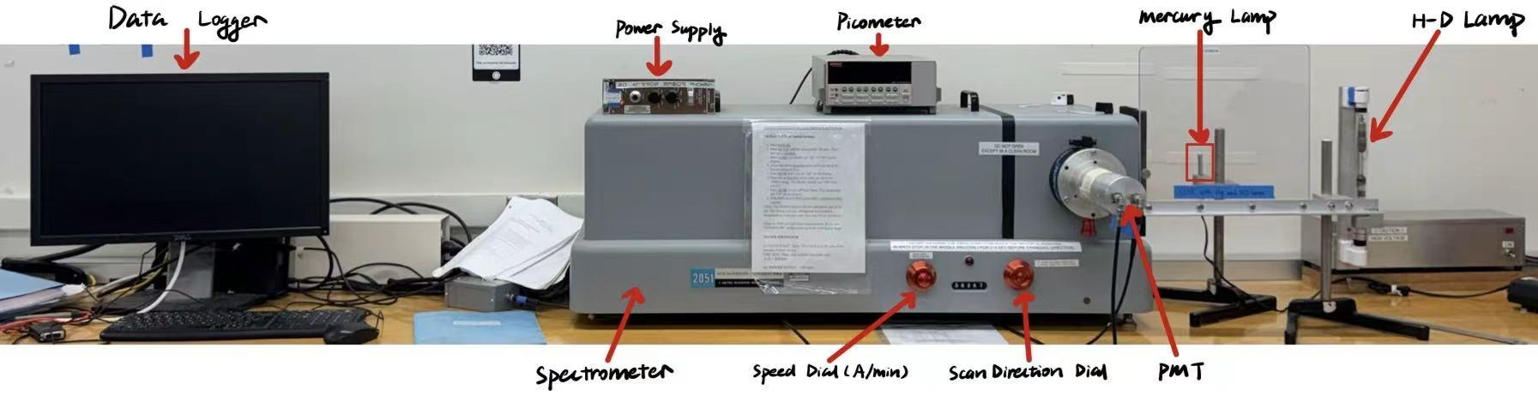

Experimental Setup:

13:45 Set the PMT slit( Left figure) and spectrometer slit (right 2 pictures) widths to 30 micrometers.

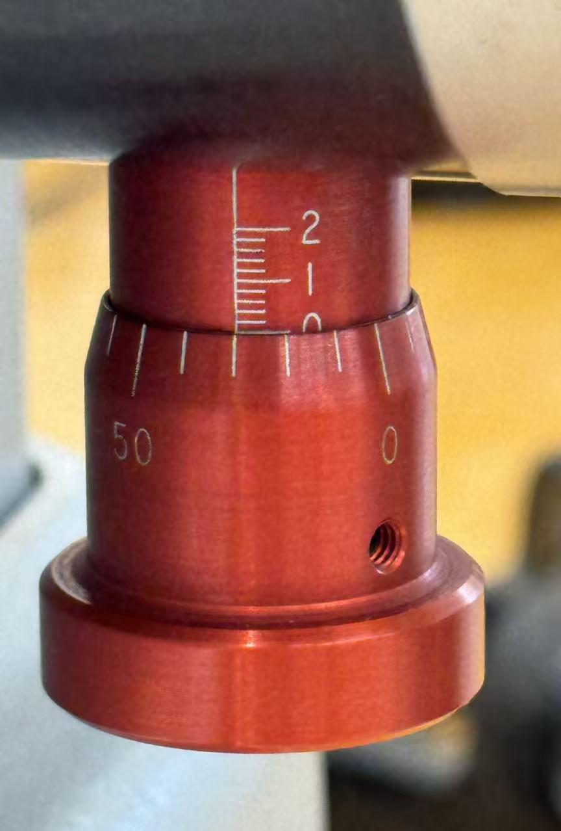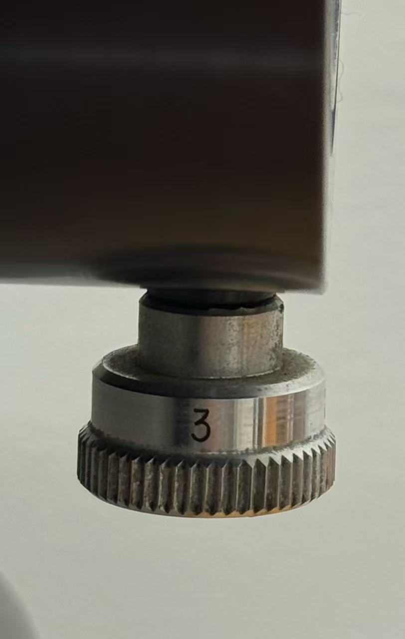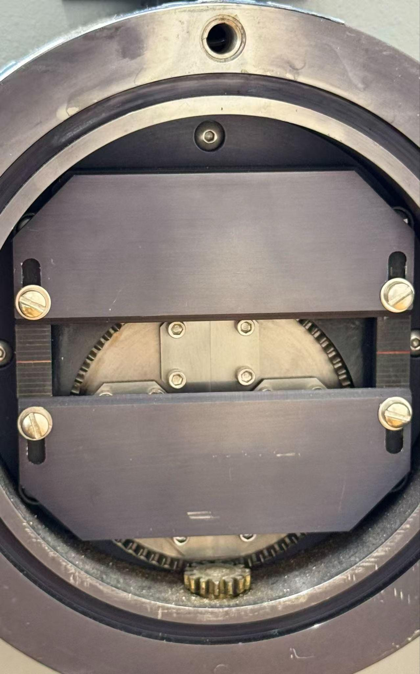

13:57 Place the Hg lamp at $6\frac{7}{8} inch$ from the spectrometer slit.

14:05 ensured that the PMT shutter and the spectrometer slit shutter were open.

14:06 Familiarize with the picoammeter by following the turn-on procedure (left figure) line-by-line. The initialized Picoammeter is shown below on the right.

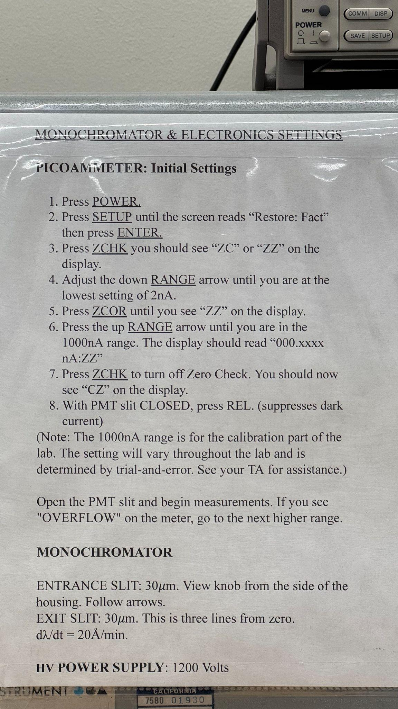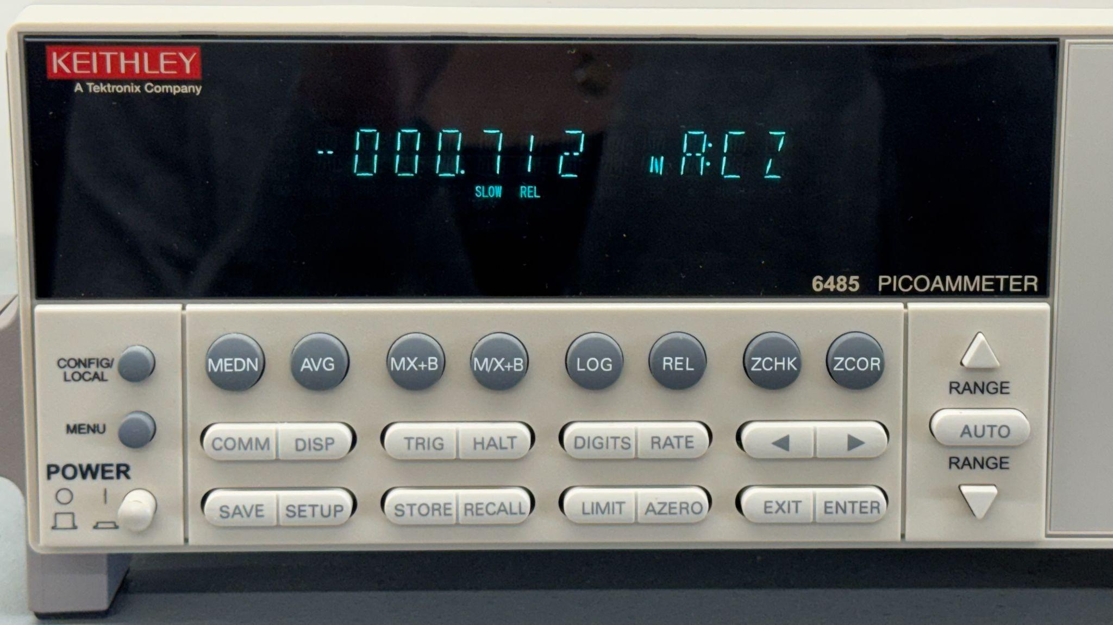

14:23 Sweep the spectrometer to 6263 Å, the second-order diffraction peak.

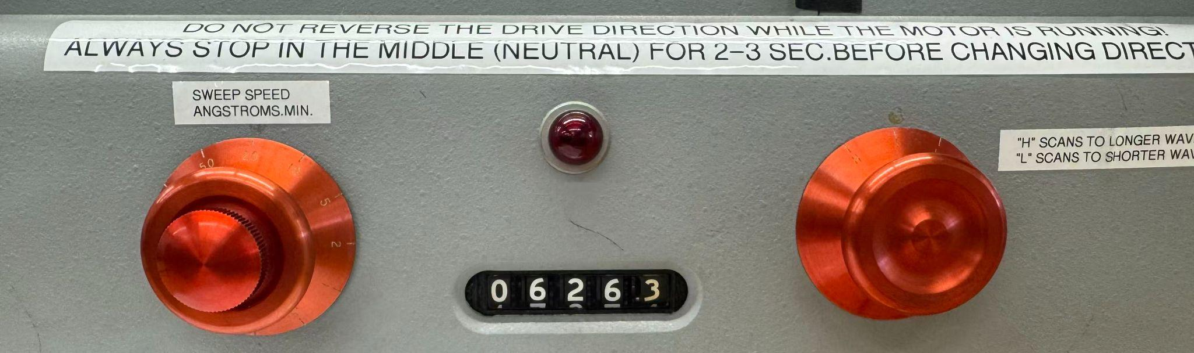

14:25 realized that I did not initialize the picoammeter with the mercury lamp on. Turned on the mercury lamp and redid the turn-on procedure of the picoammeter.

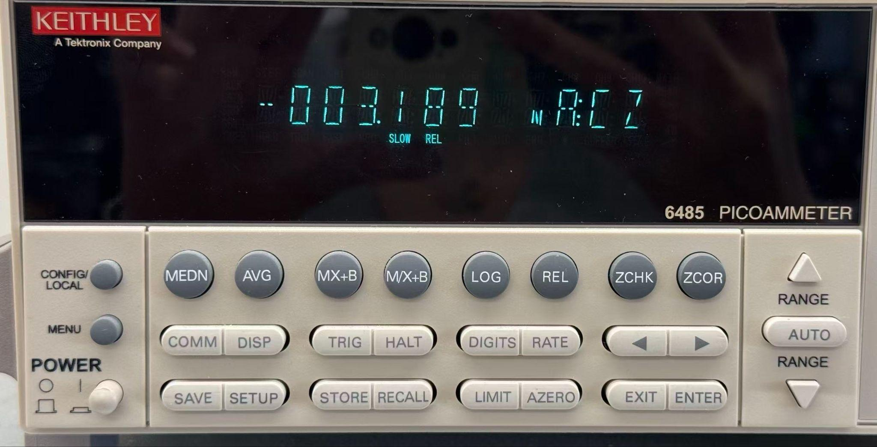

14:34 realized that I should have been using the Hg lamp instead of the mercury lamp for the whole time.

14:40 realized that Hg lamp is the mercury lamp, thank goodness.

14:50 got the spectrometer on the peak at around 6261 Å by observing the maximum current on the picoammeter reaching $0.355μA$. The current reading on the spectrometer is as shown below

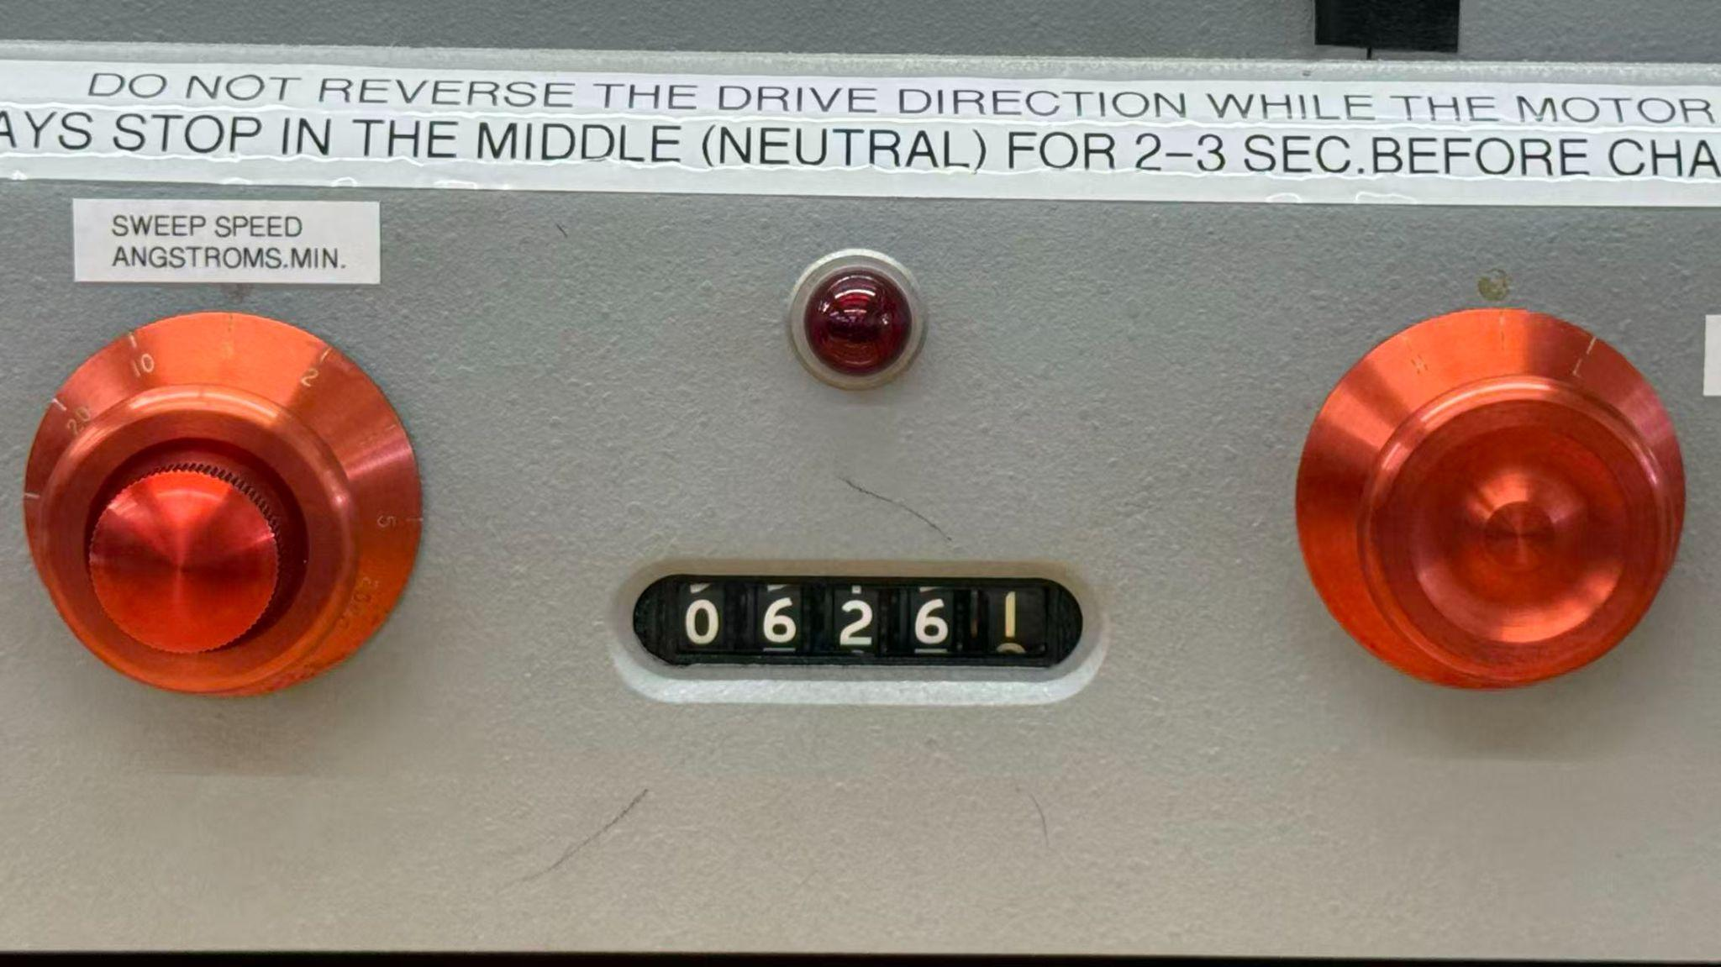

15:01 The maximum reading on the picoammeter has reached up to $1.00μA$ when the Hg lamp is around 2 inches away from the slit. I noticed that under the same horizontal displacement across to the slit, the vertical distance also changes the peak value significantly.

15:11 Somehow I should have run the log first and then moved the position of the Hg lamp, but I found the highest peak by moving the Hg lamp first. Thankfully, double-checked with the TA, who said this order should be fine as well.

15:17 Run dataLogger. Get doubleweak while running the spectrometer at 5 Å/minute at around 6262Å. [D1_1517_Hg6261_doublet_5A_L-to-H](https://docs.google.com/spreadsheets/d/1V5HUNWsNrhSV2guar-Ti-vre2i2ManFo83rlC5IdOIc/edit?usp=sharing)

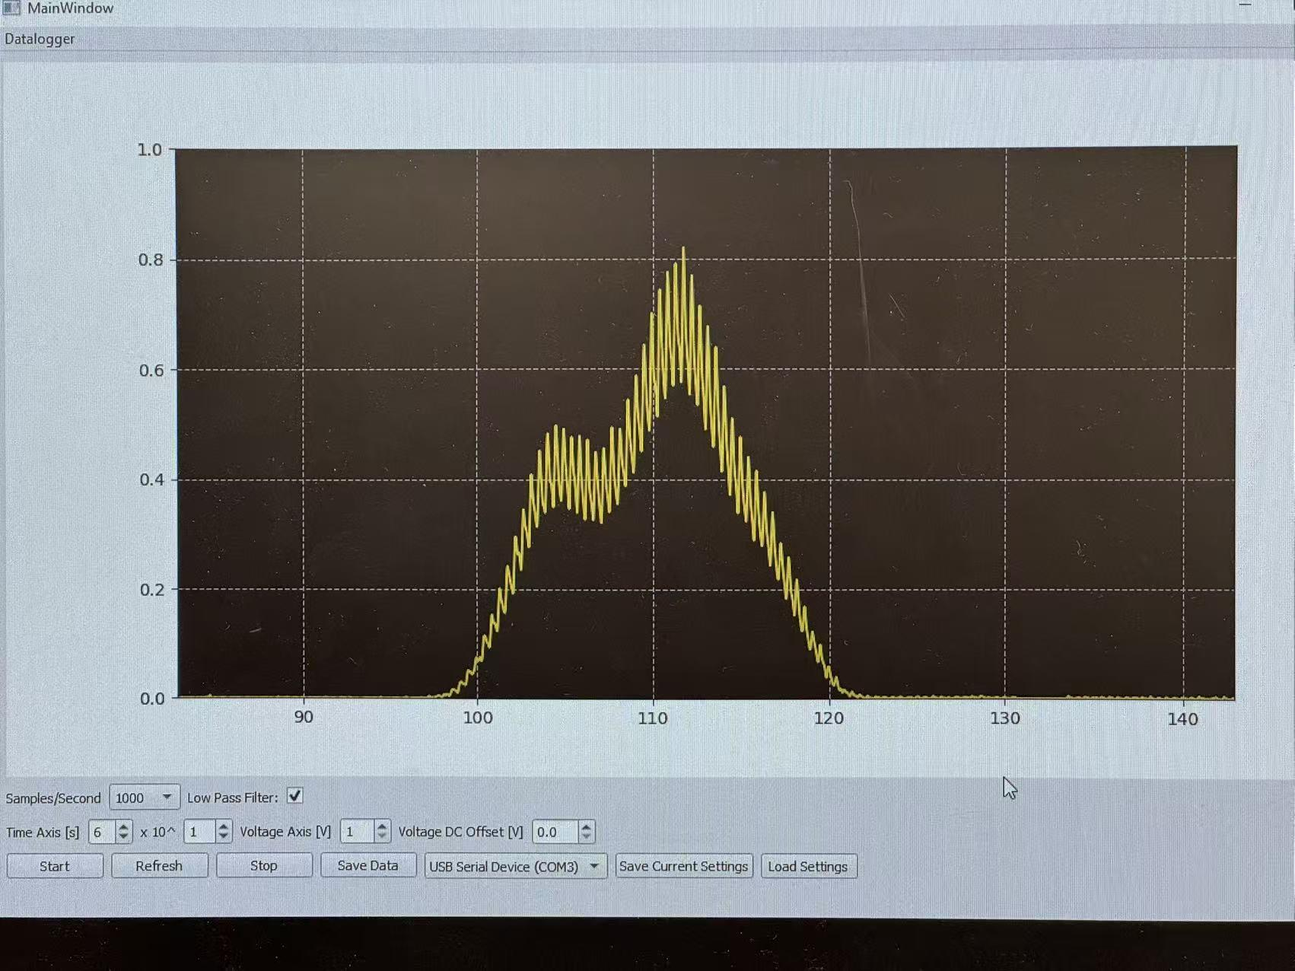

15: 30 moved the position of the Hg lamp for a bit due to noticing a low reading on the picoammeter. Forgot that shifting away from 6261Å meant to cause that difference.

15:47 reduced the sweep speed from 5Å/min to 2Å/min, aiming to separate the two peaks apart. Though they were not totally separated, they did get separated a bit. Decided to 1. Make the direction of data collection consistent (H-to-L) for the sake of future data analysis; 2. Continue reducing the sweep speed. [D1_1547_Hg6261doublet_2A_H-to-L](https://docs.google.com/spreadsheets/d/1y4sMZWf03sVyUikHv5SUU-MSTIpowSj9rxS2d9bBB60/edit?usp=sharing)

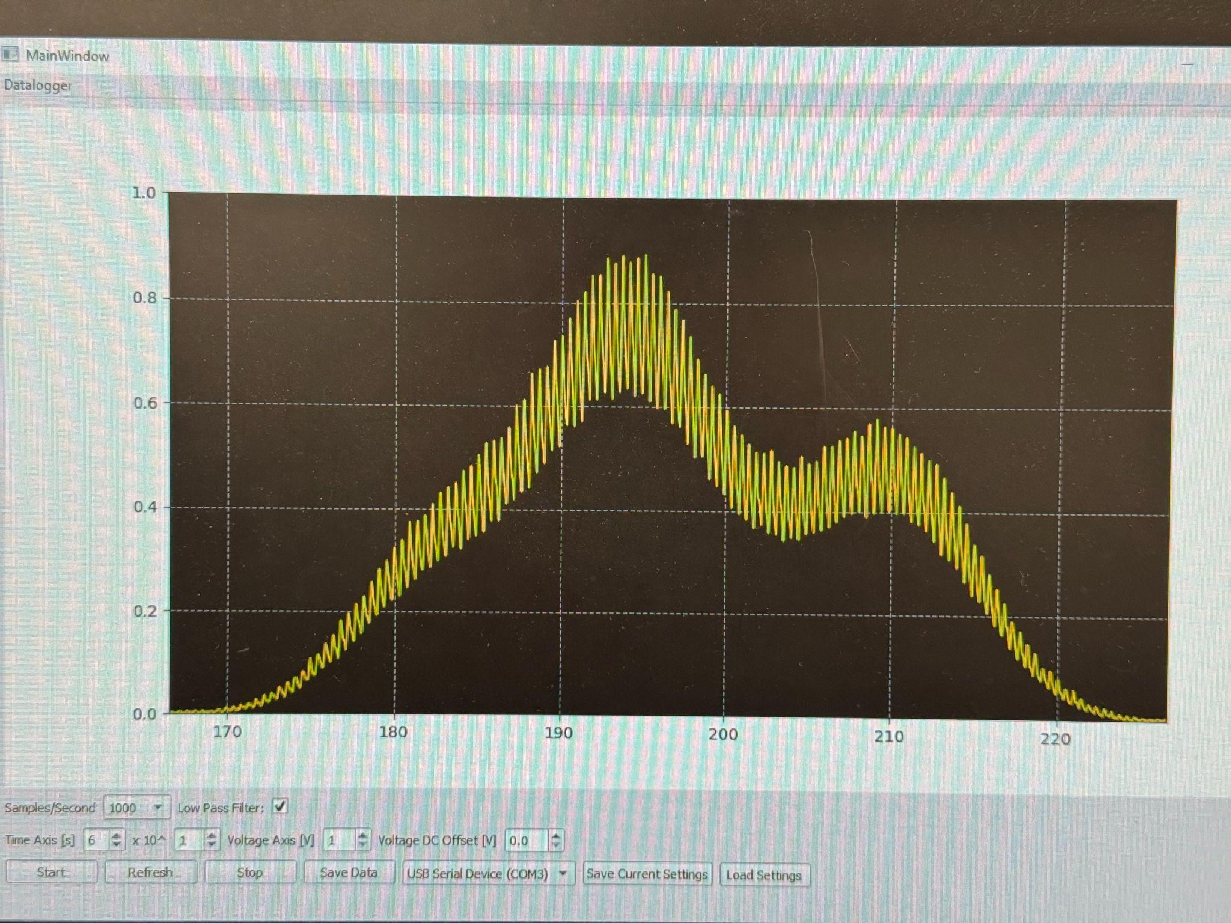

16:13 data collection at sweep speed = 1Å/min was not successful due to improper time axis. The left peak got out of the left edge, while the right peak has not yet arrived. Changed the time axis to $6×10$ and the sweep speed to 0.5Å/min.

16:26 realized that the peak around 6261Å is a doublet, which means that the two peaks would not be separated. The picture in the appendix A is misleading. The time axis changed to 300s. [D1_1625_Hg6261_doublet_0.5A_H-to-L](https://docs.google.com/spreadsheets/d/1re0gYmzUGGOduf--FCcncA3ya8VwU-sELOUgEmt7WP8/edit?usp=sharing)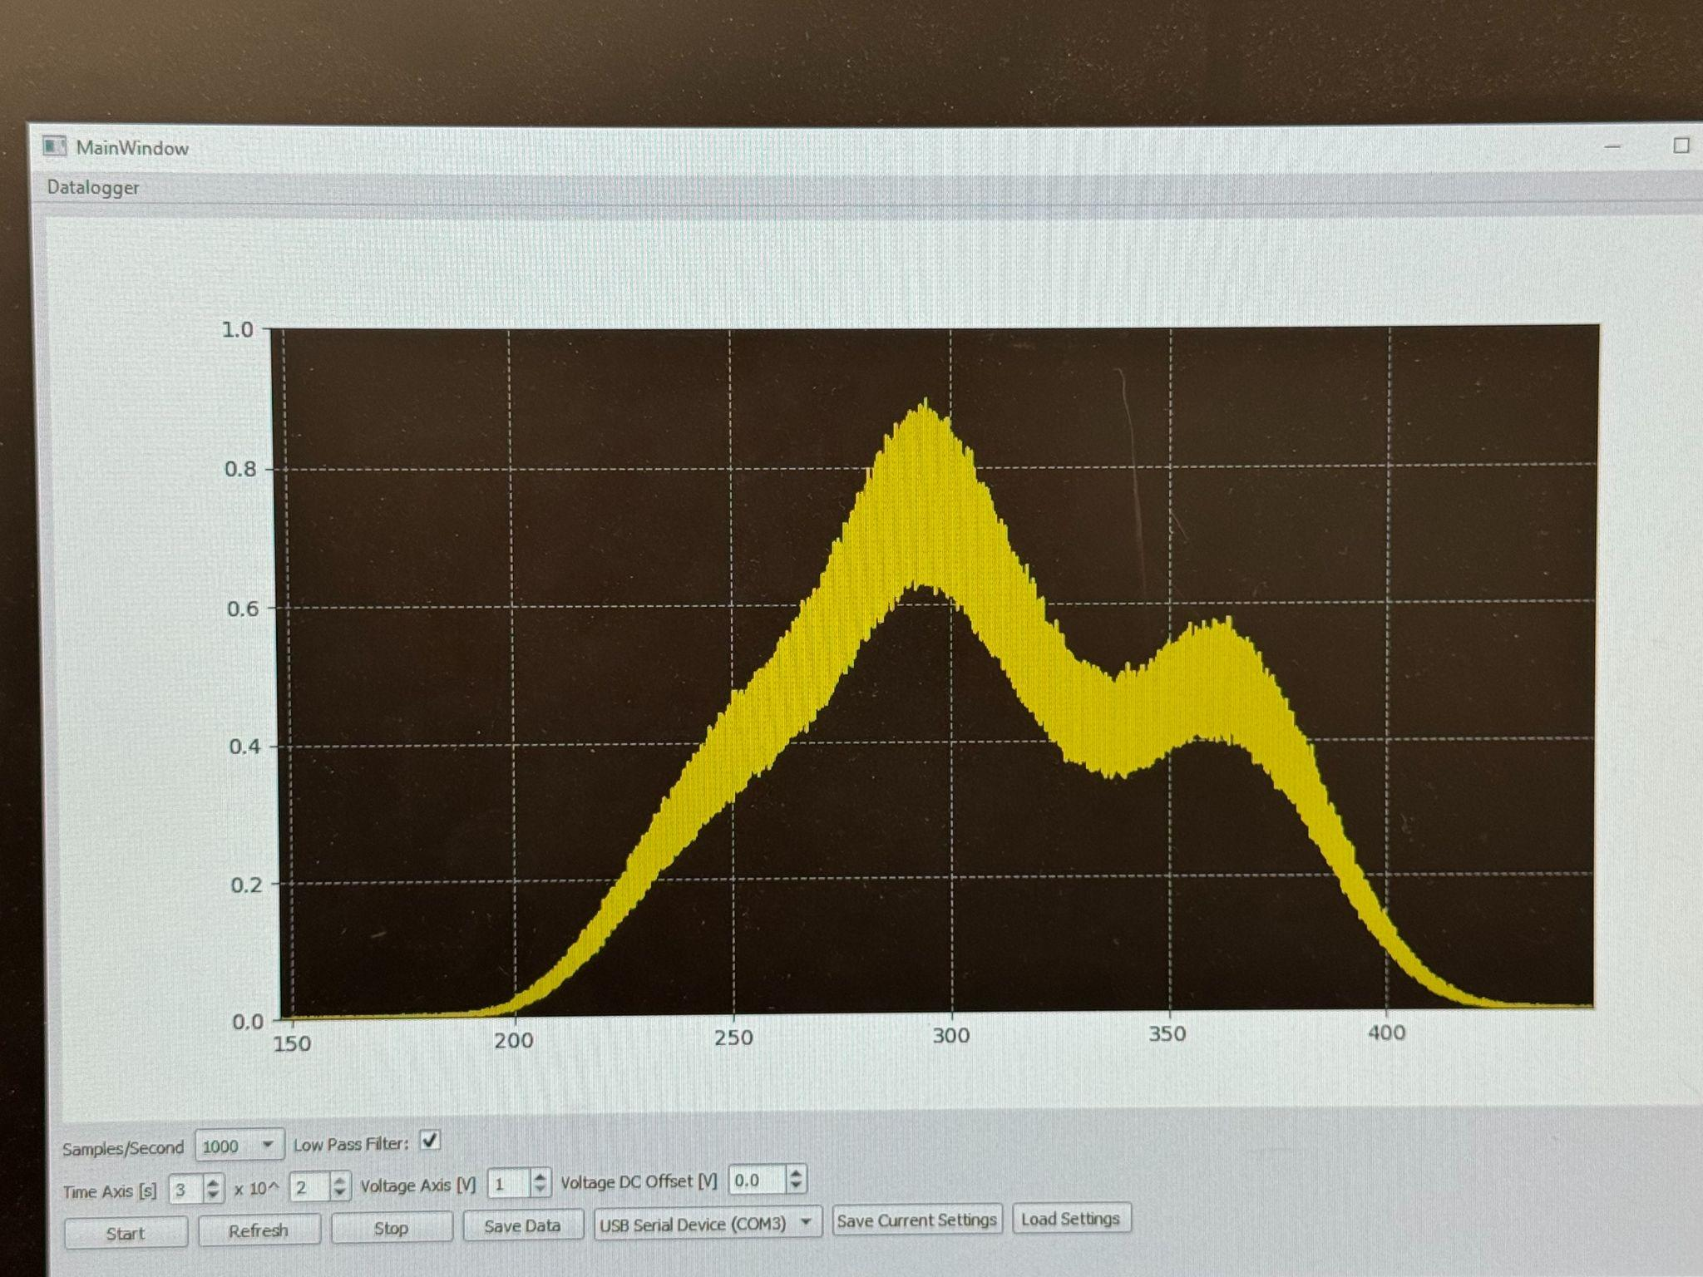

16:34 collected recordings of the doublet and the peak located at 6251.4 Å. The peak is identified at around 6249Å. It is a single peak as expected. Next, I will record at the sweep speed of 0.5Å to get the most accurate measurement. The time axis has been changed to 30s.

[D1_1633_Hg6251_single-peak_5A_H-to-L](https://docs.google.com/spreadsheets/d/1S92LEIVDNocS3SaVerPv20UH0BGyfiJPNjBrCN_nhsQ/edit?usp=sharing)

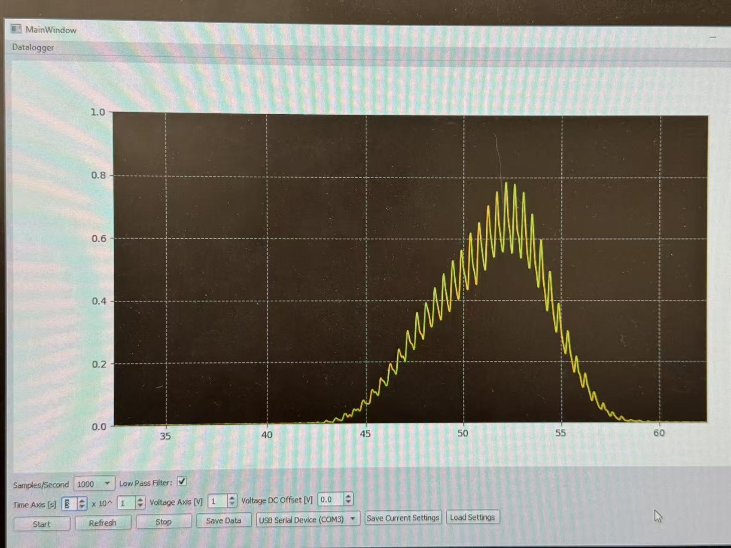

16:53 data collected for a peak located at 6251.4 Å. Time axis changed to 200s, sweep speed = 0.5Å. [D1_1651_ Hg6251_single-peak_0.5A_H-to-L](https://docs.google.com/spreadsheets/d/1wp5qmzdpoE2ixITa54WCC8-lYGoJDu0mUblphsq6k58/edit?usp=sharing)

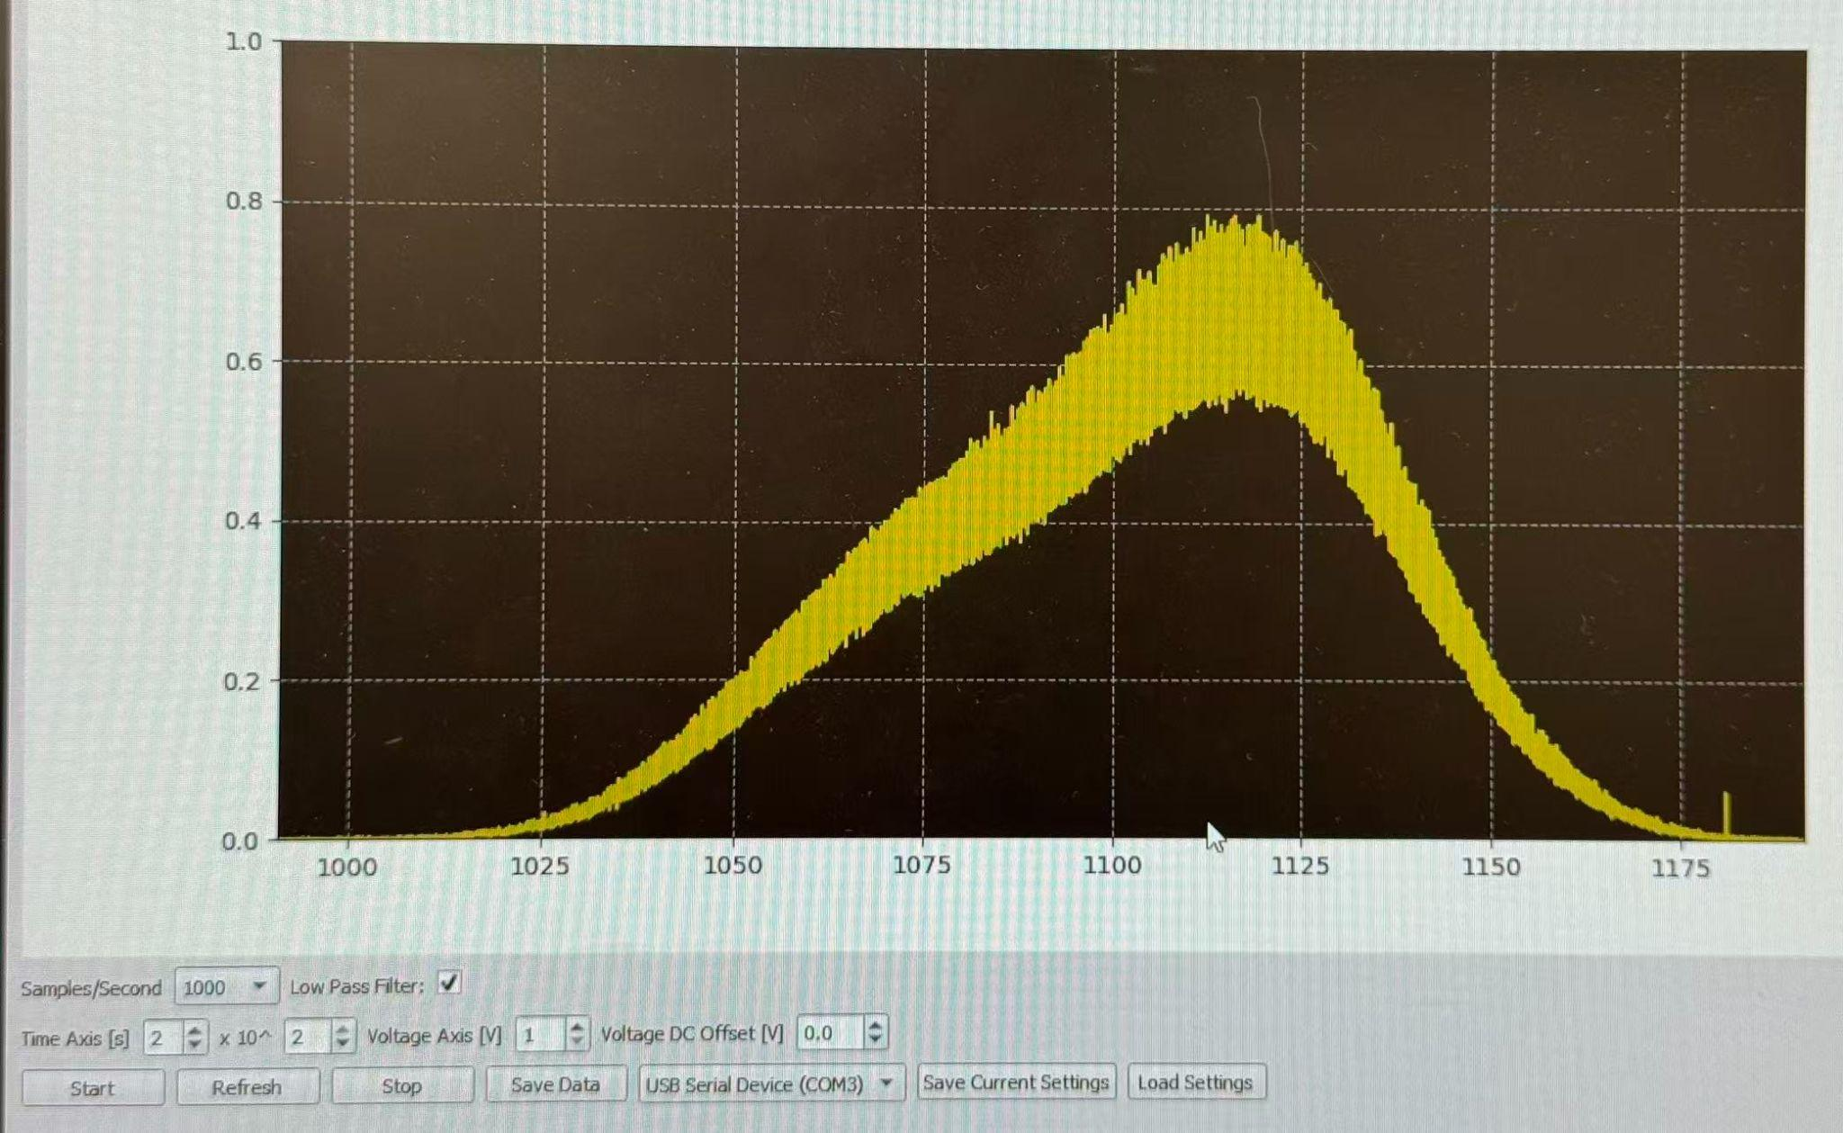

# Day 2 | 2/5/2026 Redo the Calibration

Etern Wang

13:10 arrive at the lab

13:20 Set the spectrometer slit and PMT slit to 30 microns.

13:30 make sure the mirrors of the spectrometer are set in the appropriate positions.

13:35 Open HD lamp, Datalogger in computer

13:40 Do some initial settings of the picoammeter ( Press power button – Press SETUP until the screen reads “Restore: Fact” then press ENTER – Press ZCHK – Adjust the Range until I can see nA – Press ZCOR – Press the up Range until the nA:ZZ – Press ZCHK to turn off Zero Check – Should find “CZ” on display)

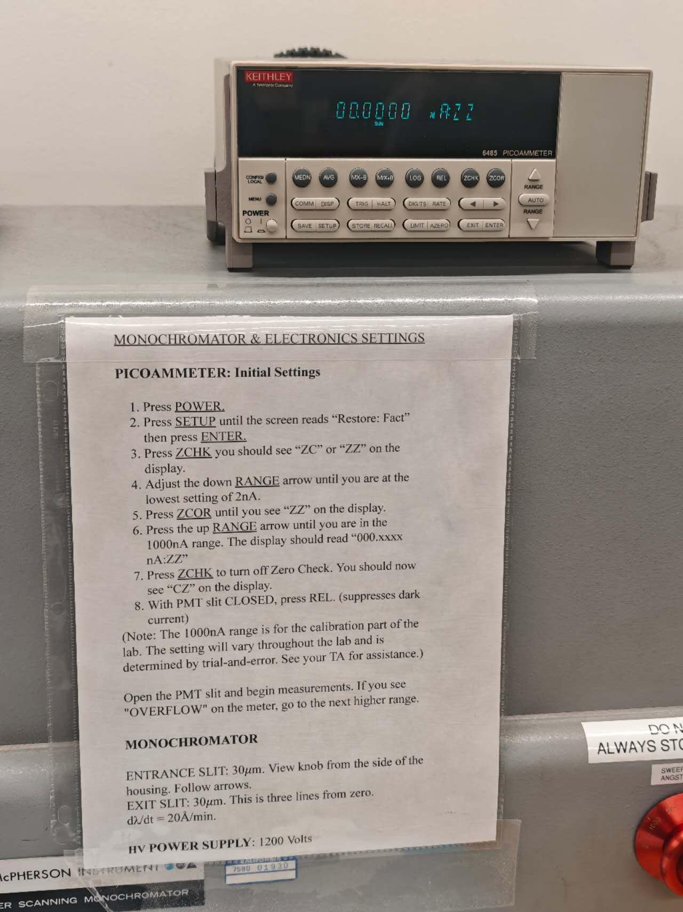

13:55 Don’t know why there is a “ZZ” at the end of Zero Check. Ask TA for help.

14:10 Click the ZCHK again, then I get the “ZZ” at the end of Zero Check.

14:20 Try to set the measuring wavelength at 6263A, but don’t know how. Ask TA for help.

14:25 Know to adjust the resolution by pulling and turning the knob to set. Set it to 100 A/ minute in order to get 6263A on the display more quickly.

14:30 When the Measured wavelength is about 6260A, start measuring by using the Datalogger.

14:50 Weird! NO Current!

14:55 Ask TA for help. I am using the unknown light source!

15:05 Set up the Hg light, put it in front of the PMT, and open it.

15:10 Running the spectrometer at 100 A/minute to find the 6260A more quickly. Notice: Do Not reverse the drive direction while the motor is on. Always Stop in the middle for 2-3 sec before changing.

15:12 Find that the current is overflowing. Adjust the range:

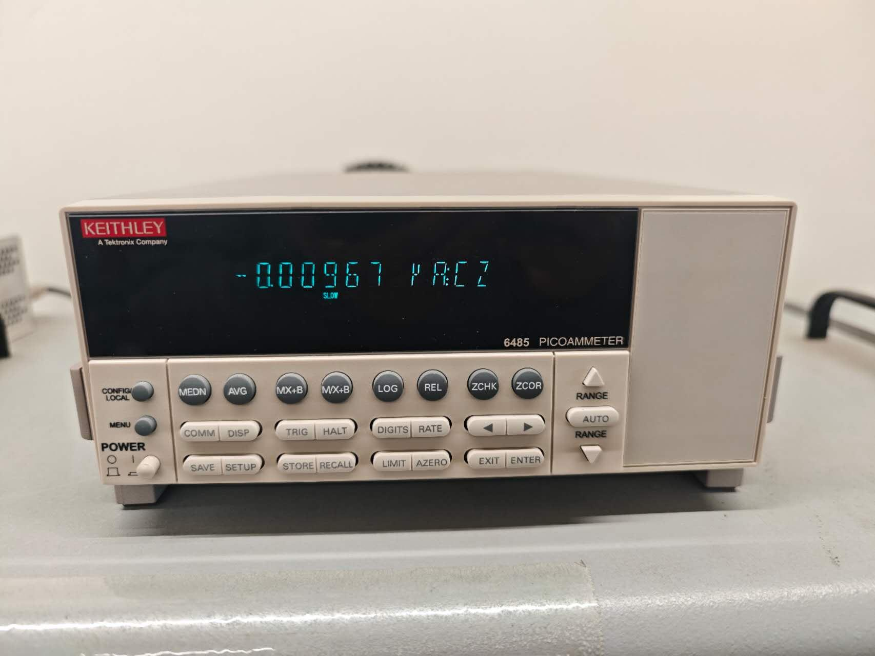

15: 20: Find the Peak at 6261A. When I start measuring, set the speed to 5A/min for a more precise diagram [Etern hg lamp 6261 1st.csv](https://drive.google.com/file/d/1DasjgGfMAEtvS5IZpCeVgj32FI3LHd0y/view?usp=drivesdk)

.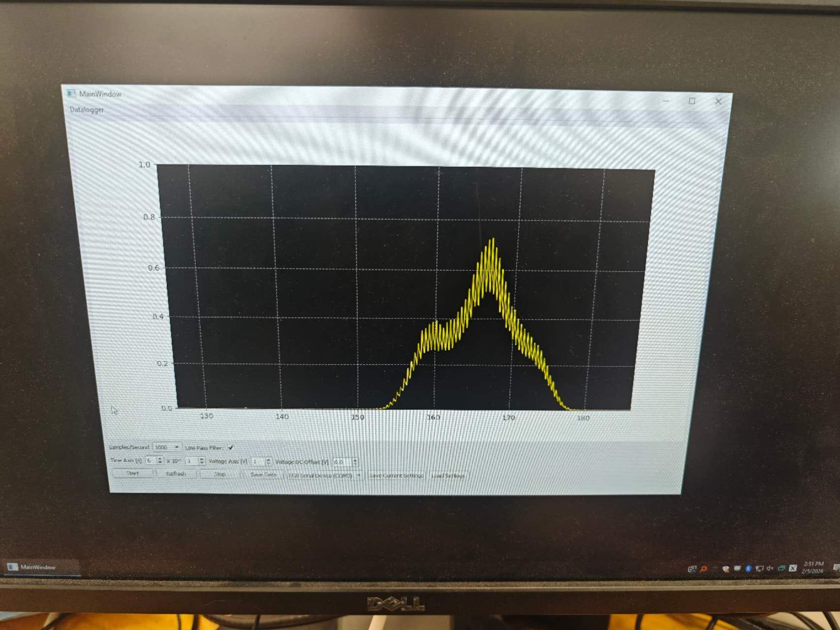

15: 30: Redo it by setting the Voltage Axis to 3 [hg lamp 6261 2nd.csv](https://drive.google.com/file/d/1RlRbo0aqufn7jnTab2b_BLTry93sMpij/view?usp=drivesdk)

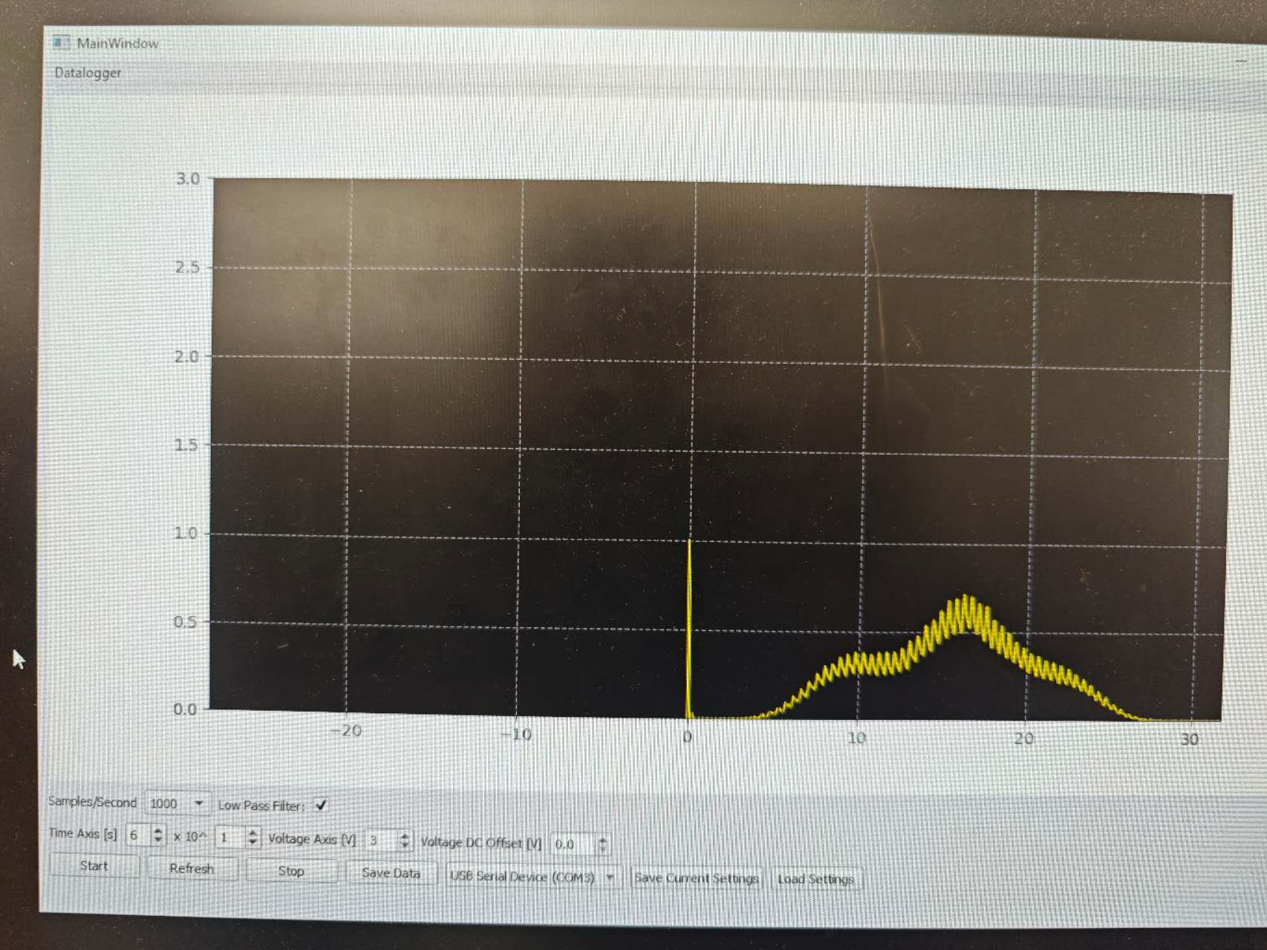

15:40: Make several chart recordings of the doublet and the peak located at 6251.4 A

15:42: Can’t find any peak on 6251.

15:45: Try to start at 6250. Success! [6250 VA 1.csv](https://drive.google.com/file/d/1YLF30VAuU4q9W4iuC5xswLMT1P2dunV6/view?usp=drivesdk)

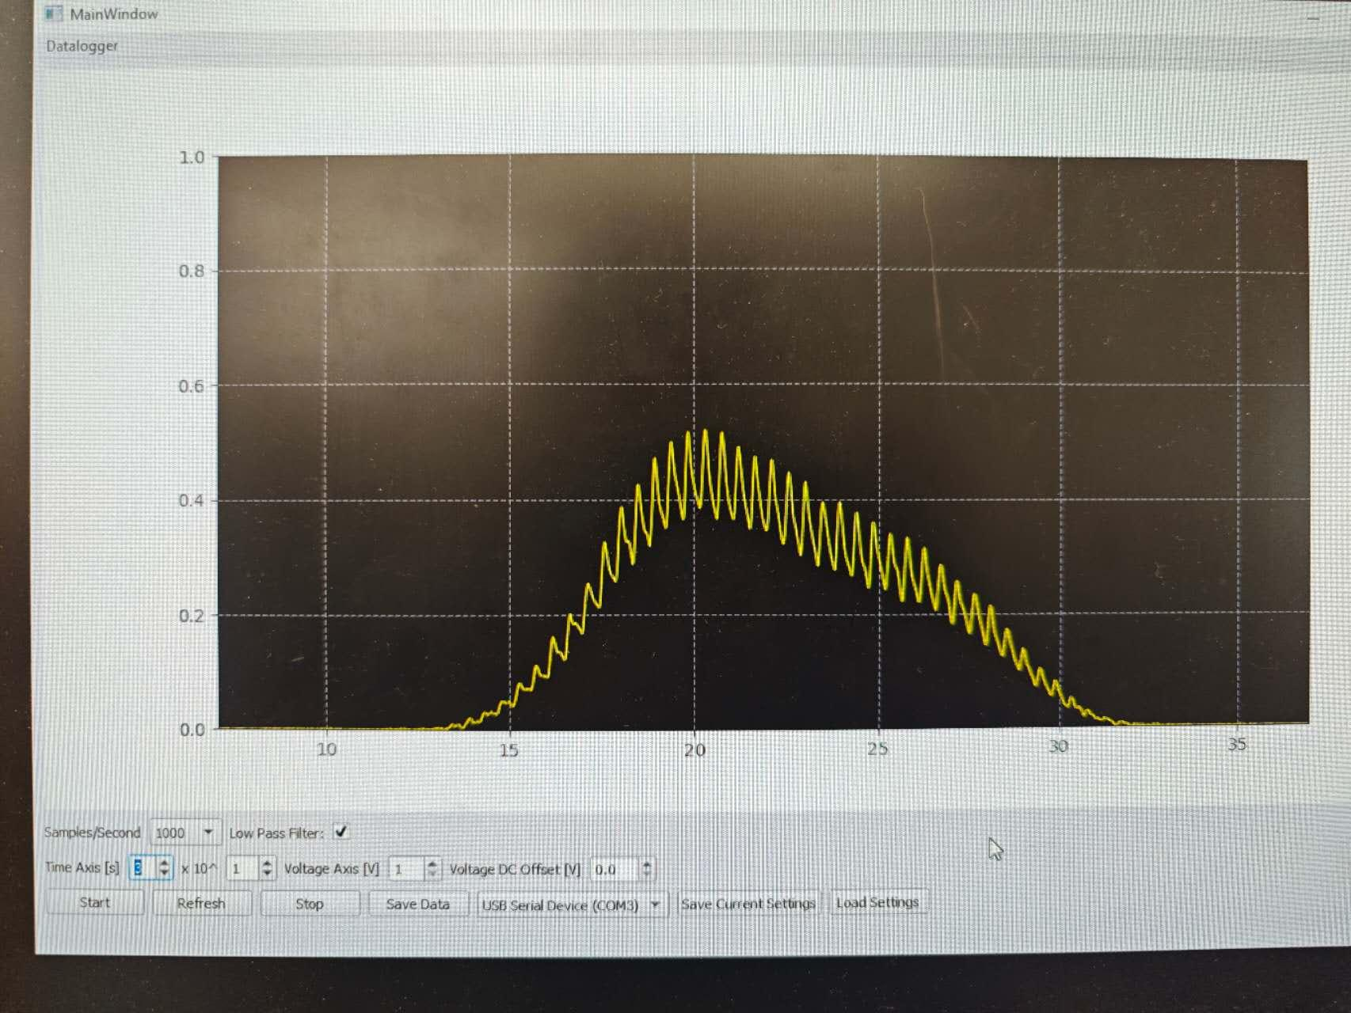

15: 50 Set the VA to 3, for another diagram: [hg lamp 6250 Aoltage axis 3.csv](https://drive.google.com/file/d/18Kd_KQwsdqwlqHuDRnhYovBeRAtv8kdK/view?usp=drivesdk)

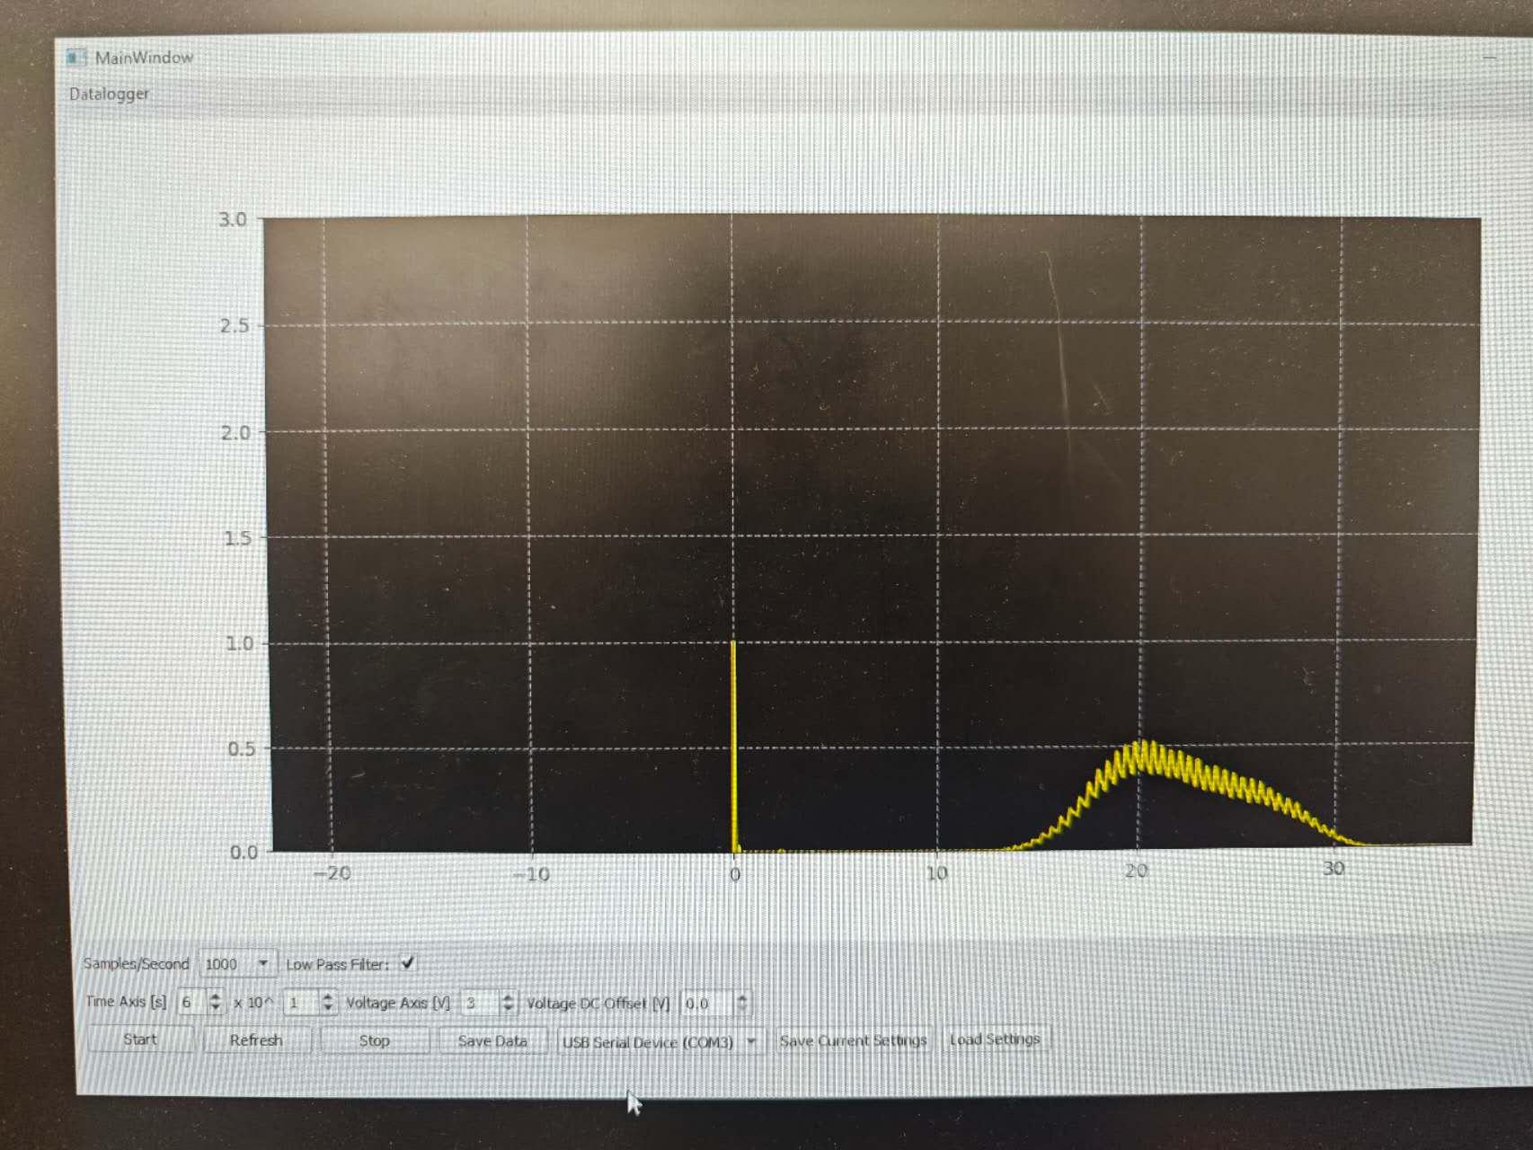

16:00: log in my Google drive, and restore all the csv. Data on the computer to my Google drive.

16:10: Close the light source. Turn off the computer. Turn off the PMT. Turn off the picoammeter.

16:15 Double check whether I missed something and look forward to measuring the isotope shift with my partner CiCi next week!

# Day 3 | 2/10/2026

13:04 Set up the experiment

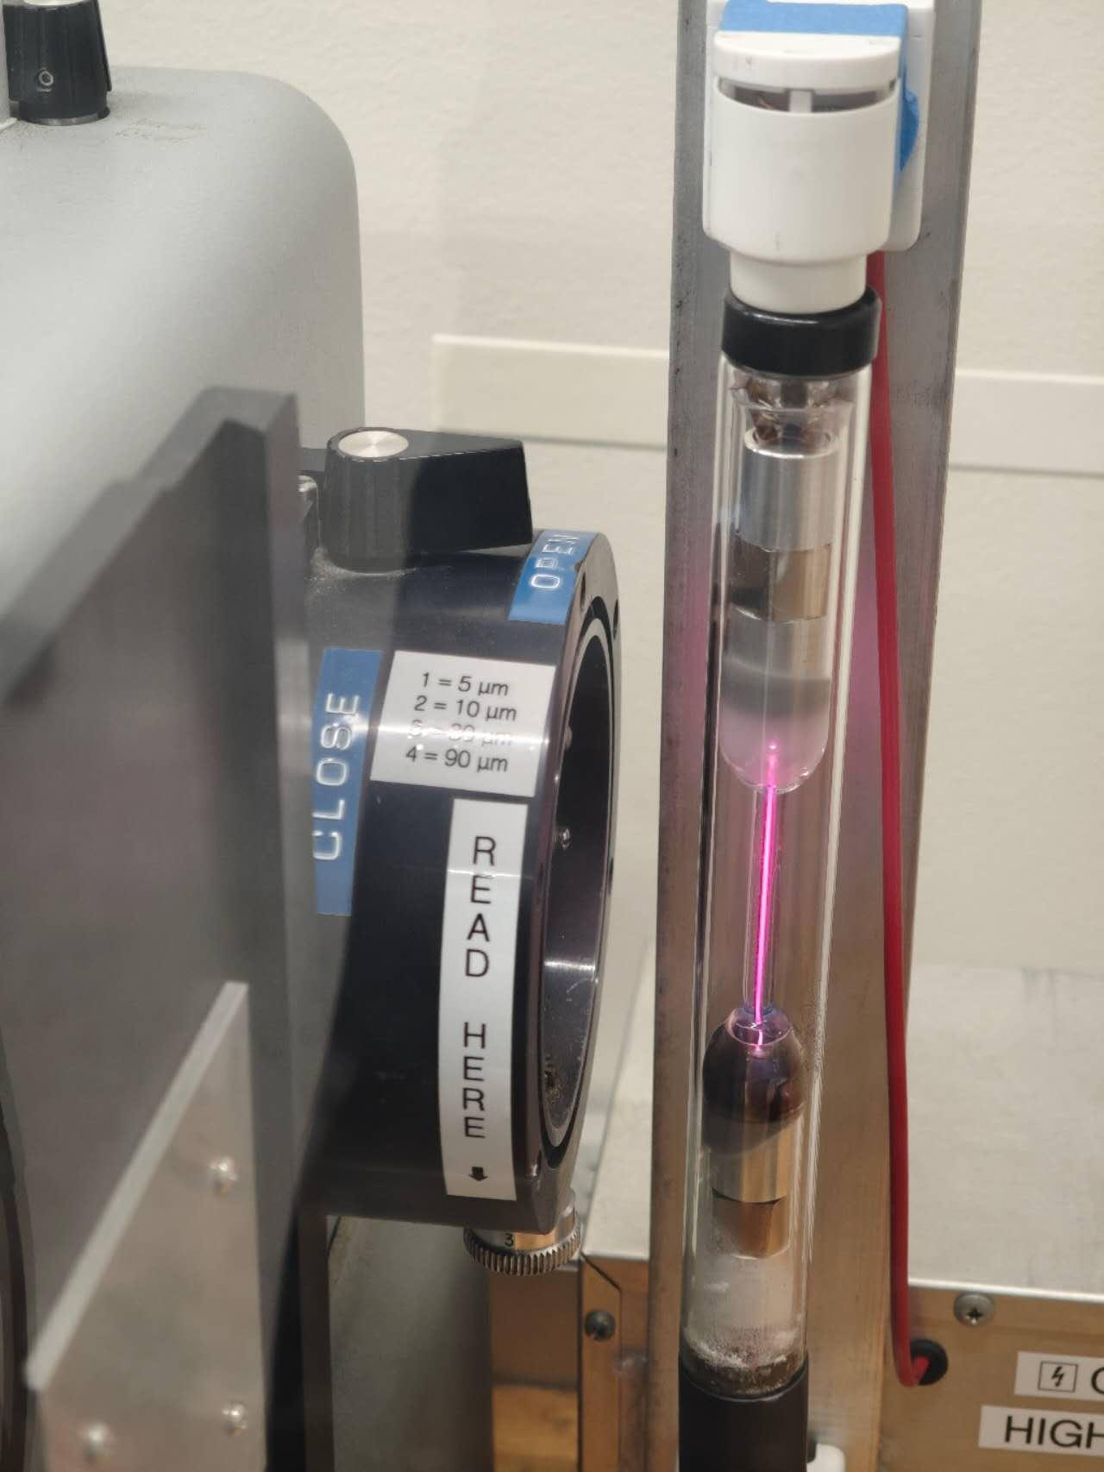

13:08 Picoammeter: Initial settings. Make sure there is "CZ"on the display.

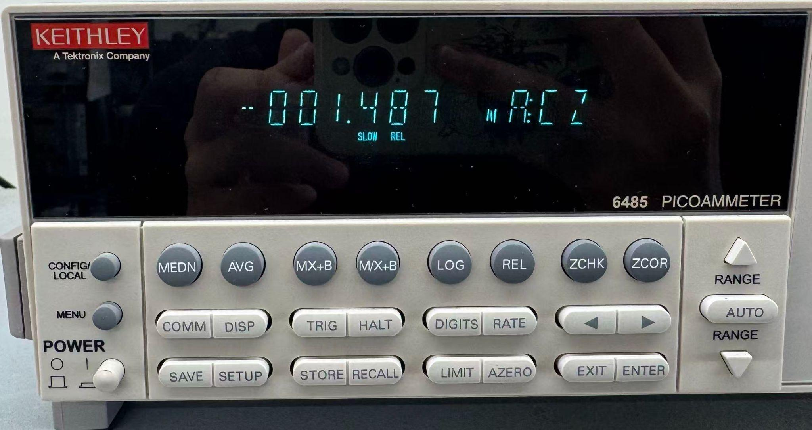

13:15 Set the measured wavelength to 3889. We did not notice a peak while quickly going through this wavelength. We decided to start from the highest wavelength instead.

13:24 we found the first doublet at 6562 Å. Data collected [1324 6562 H-L.csv](https://drive.google.com/file/d/1CVrxniH6Xug1GauNOmGZkqoF5cIiSmbx/view?usp=drive_link)

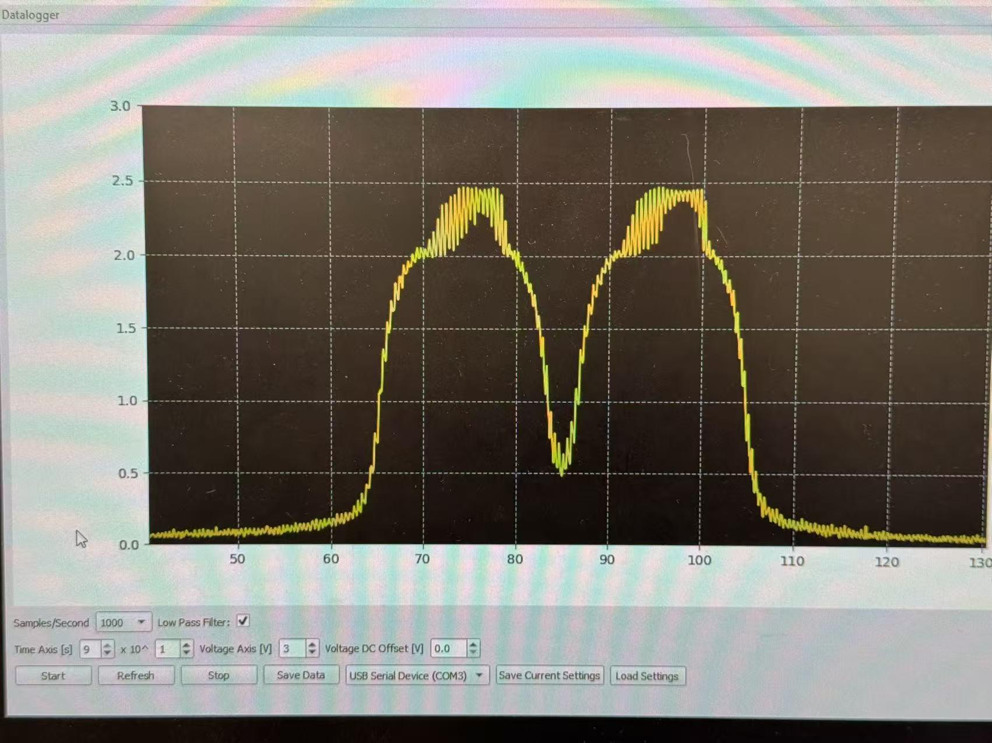

13:28 second doublet found at 4859 Å. Data collected [1328 4859 L-H.csv](https://drive.google.com/file/d/1B-sKT6rDLPyWvmoydiLk9XM2SkLrOUKw/view?usp=drive_link)

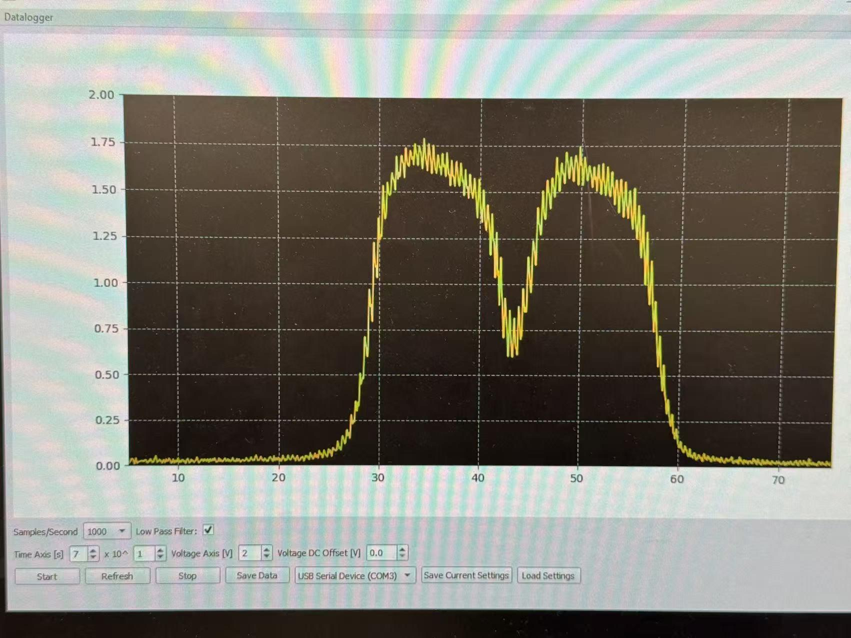

13:34 3rd doublet found at 4337Å. Data collected. [1333 4337 L-H.csv](https://drive.google.com/file/d/1H53RS6uUq-P1_14awIxyZ1Q27s_HzQXu/view?usp=drive_link)

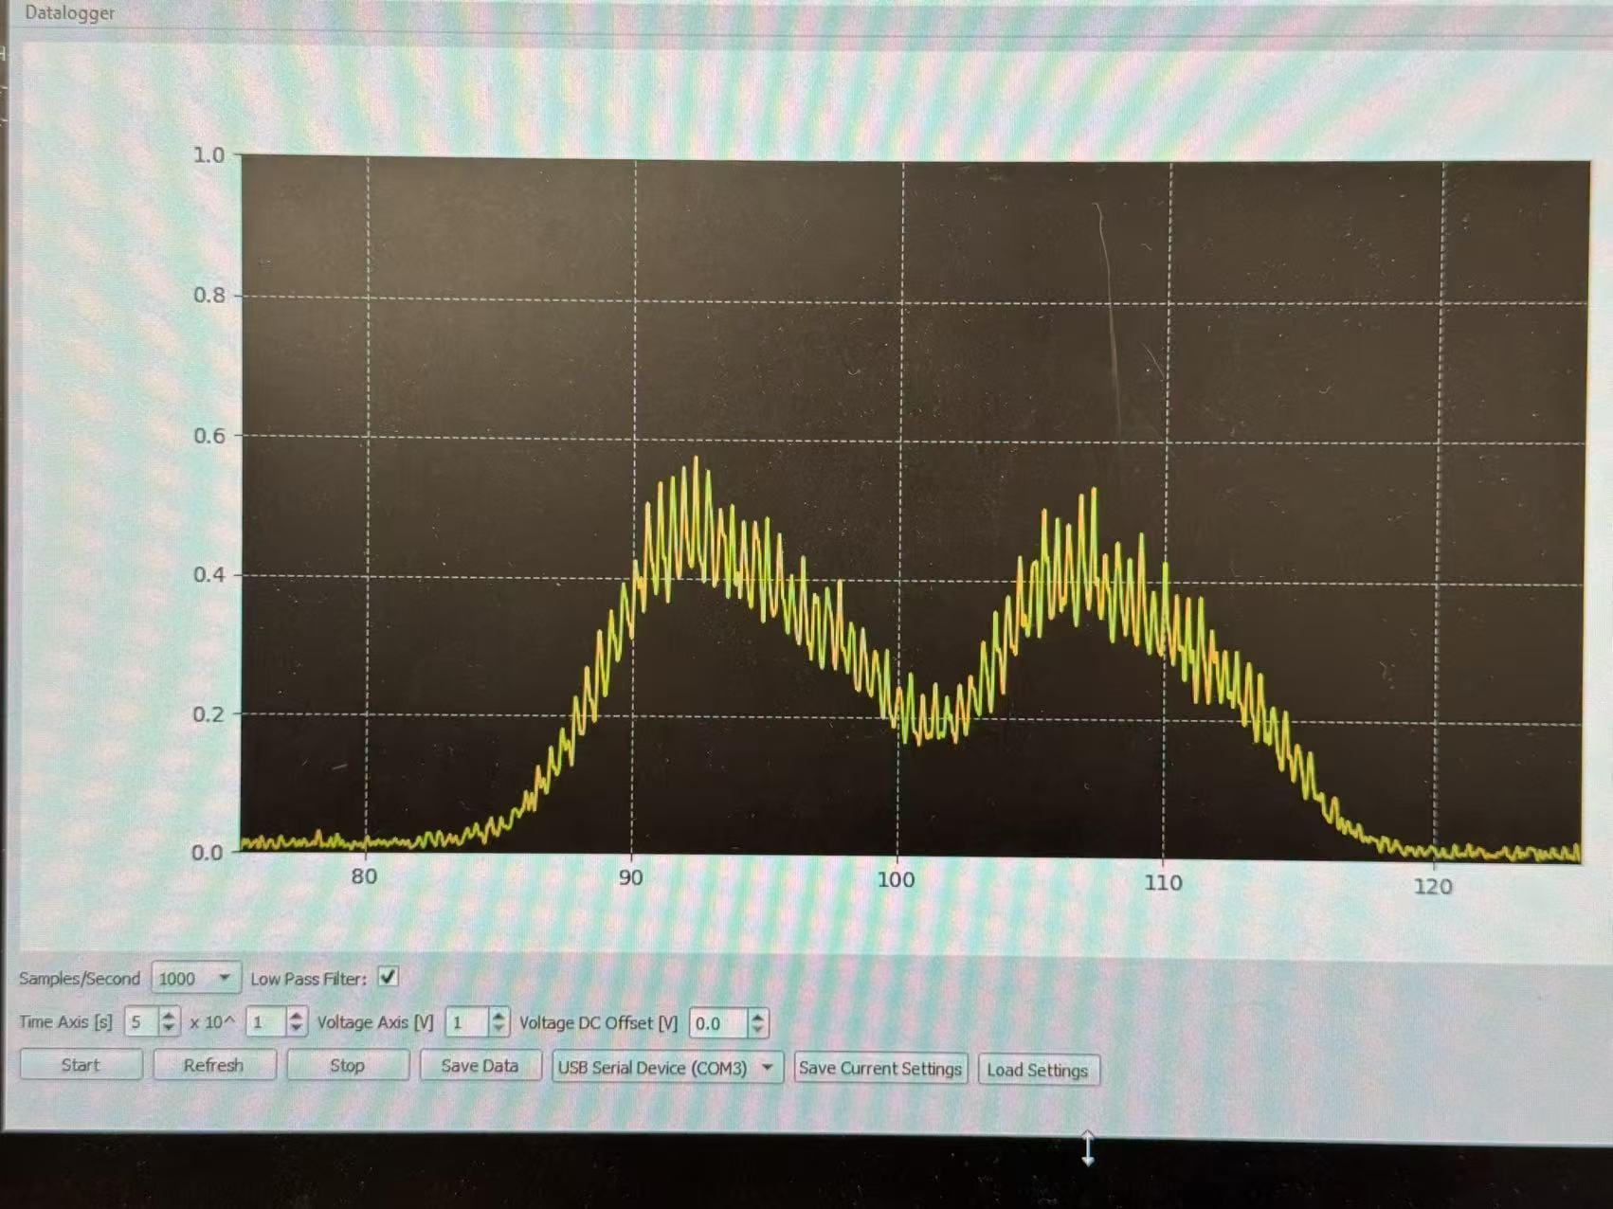

13:39 noticed a weak doublet at around 4098Å while scanning with 20 sweep speed.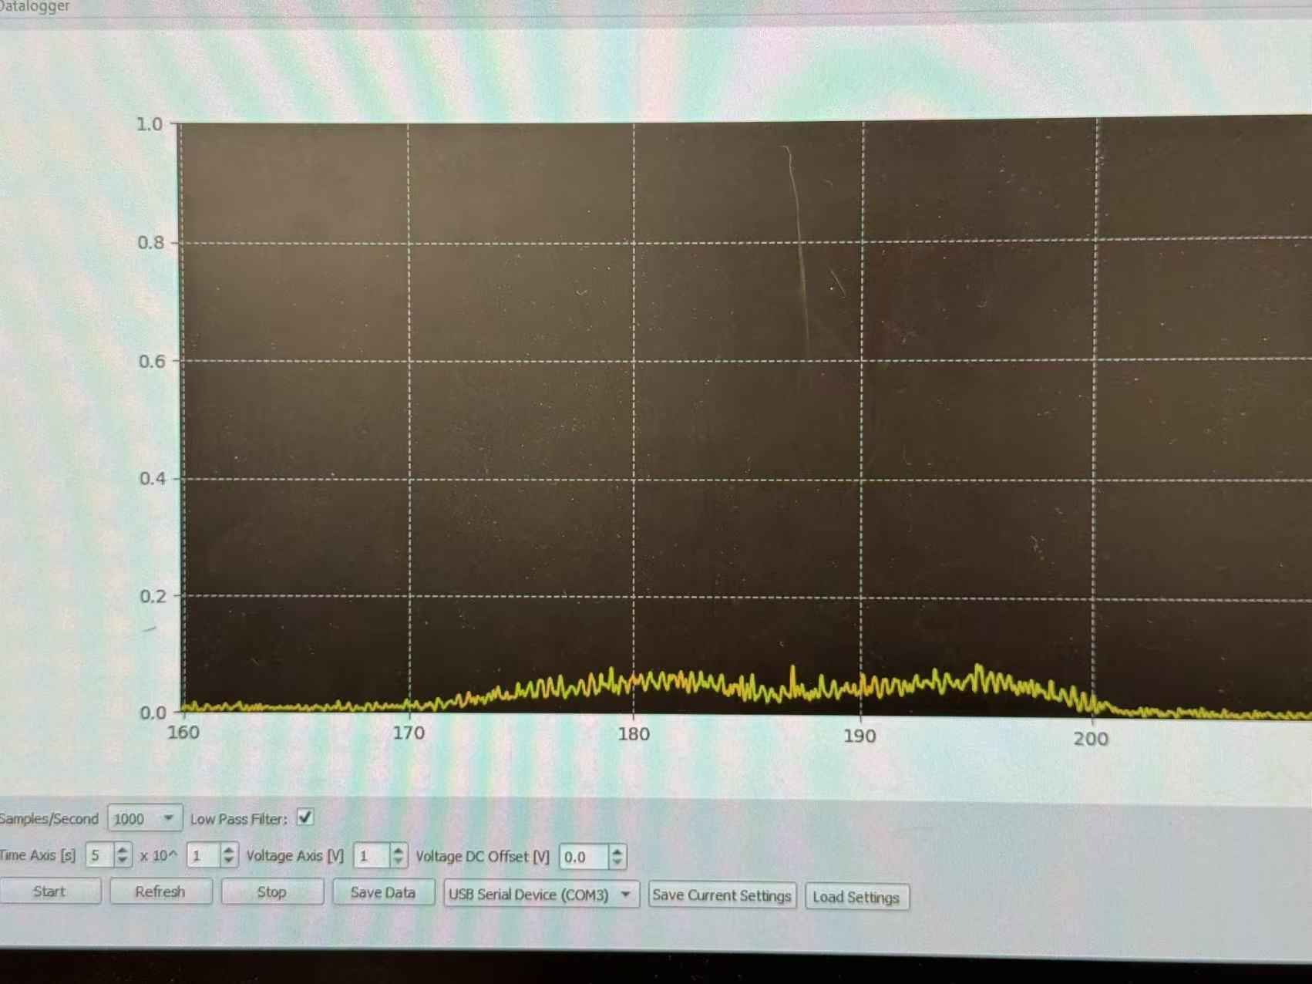

13:41 slowed down the sweep speed for more accurate data at 4098Å. Data collected. We noticed that the signal becomes weaker as we get to lower wavelengths, even in the case where we are already using the voltage axis that demonstrates the data in the most significant way.

[1341 4098 L-H.csv](https://drive.google.com/file/d/1QR1XT5iO2H2xvocILHCfDE-S630yw413/view?usp=drive_link)

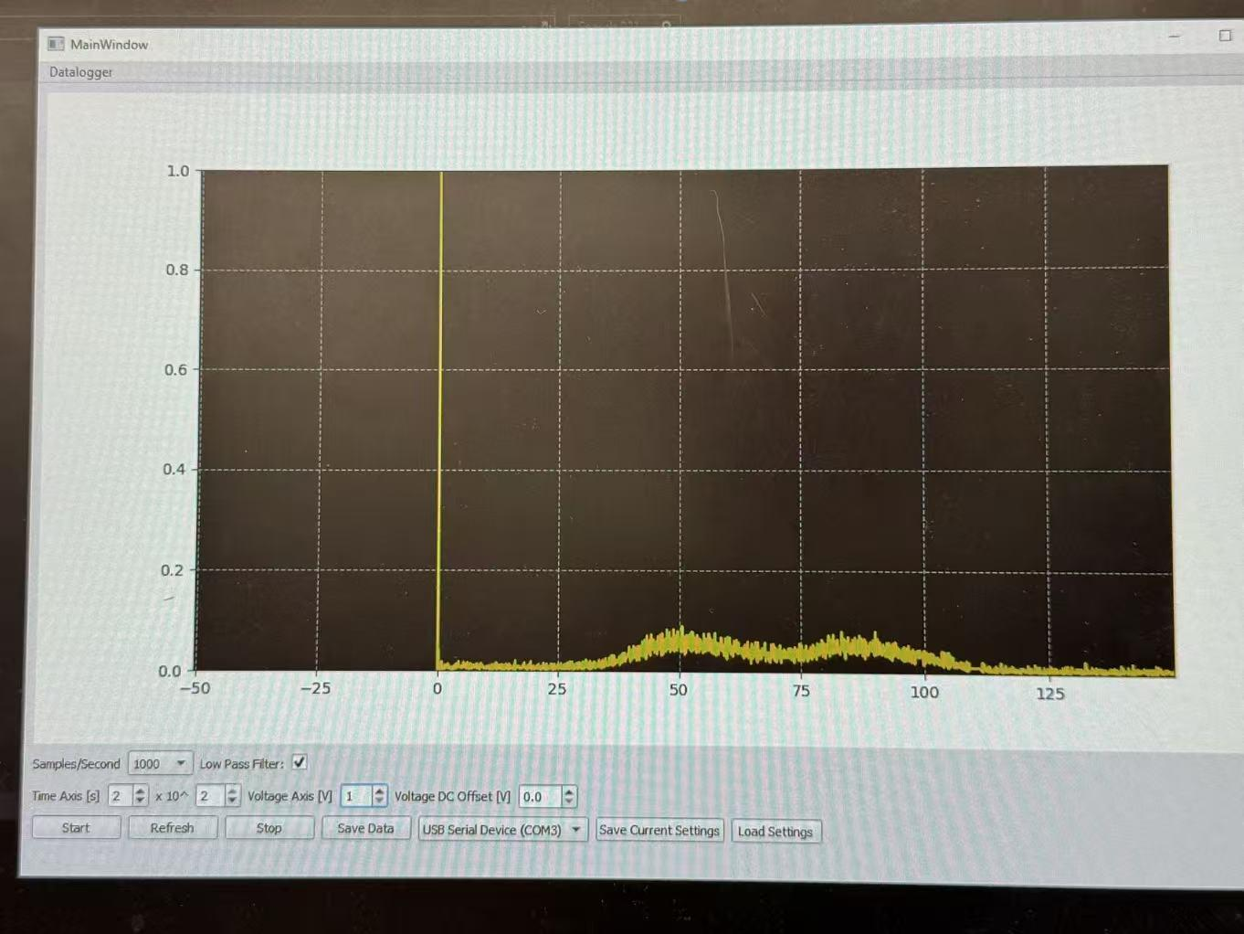

13:50 We didn’t see anything as the wavelength continued to go down. Mara suggested changing to another H-D lamp, so we are waiting for the lamp to cool down.

14:03 As we came slowly 3970Å around we still did not see anything even in the 20 nA range of the picoammeter.

14:27 With Mara’s and the help from previous students, we change the slit to 4=90μA to see if there will be any difference.

14:36 Mara reminds us that we might not align the center of the lamp. We lined them up and try screening slowly again.

15:16 After troubleshooting for the past 40 minutes, we were still unable to see peaks at and under 3970Å. Mara said the lab manager will repair the system and we will progress the wavelengths at and below 3970Å in the next lab section.

15:18 We decided to increase the trials of measurement for previous peaks.

15:25 The current lamp were not able to demonstrate the 4098Å peak which we have previously found. We reported those issues to Mara and decided to push forward with data collection next lab session.

15:28 data saved.

# Uncertainty Propagation and Data Analysis

Since we only have one set of data, we need to fit Gaussian to get the peak center in time. We use the y(t) to do the double Gaussian fit:

y(t) = A1*exp(-(t-mu1)^2/(2*sigma1^2)) + A2*exp(-(t-mu2)^2/(2*sigma2^2)) + C + D*t

* mu1, mu2 = two peak centers (peak positions) in time (seconds)
* sigma1, sigma2 = widths of the peaks in time units
* C + D*t = baseline / background

Result:

mu1 = 74.28185 s dmu1 = 0.00939 s

mu2 = 96.82749 s dmu2 = 0.01196 s

The set up is 5 Å/min, so dλ/dt = 5 Å/min = (5/60) Å/s = 0.0833333 Å/s

λ(t) = λ_ref + (dλ/dt) * (t - t_ref)

λ_H = 6562.000 Å at t_ref = mu2

λ(t) = 6562.000 + (0.0833333) * (t - mu2)

Therefore, λ(t) = 6562.000 + (0.0833333) * (t - mu2)

λ2 = 6562.000 + 0.0833333*(mu2 - mu2) = 6562.000 Å

mean wavelength (Peak 2) = 6562.000 Å

Delta_t = mu2 - mu1

= 96.82749 - 74.28185

= 22.54564 s

Delta_λ = (dλ/dt)*Delta_t

= 0.0833333 * 22.54564

= 1.87880 Å

λ1 = 6562.000 - 1.87880 = 6560.1212 Å

mean wavelength (Peak 1) = 6560.1212 Å

Because λ = const + (dλ/dt)*t is linear, dλ = (dλ/dt) * dt Var(λ) = (dλ)^2

dλ2 = 0.0833333 * dmu2

= 0.0833333 * 0.01196

= 0.00099667 Å

Var(λ2) = (0.00099667)^2

= 9.933e-7 Å^2

dλ1 = 0.0833333 * dmu1

= 0.0833333 * 0.00939

= 0.00078250 Å

Var(λ1) = (0.00078250)^2

= 6.123e-7 Å^2

**Final results:**

Peak 2 (Hydrogen Hα):

mean wavelength = 6562.0000 Å

uncertainty (1σ) = 9.9667e-4 Å

variance = 9.933e-7 Å^2

Peak 1 (Deuterium Dα):

mean wavelength = 6560.1212 Å

uncertainty (1σ) = 7.8250e-4 Å

variance = 6.123e-7 Å^2

Separation:

Δλ = 1.8788 Å

For this 6562 Å doublet data, we used a double Gaussian fit to determine the peak centers more precisely in time. We modeled the signal as the sum of two Gaussian functions plus a linear background term, which accounts for baseline drift in the data. From the fit, we obtained peak centers at μ₁ = 74.28185 s and μ₂ = 96.82749 s with small fitting uncertainties. Using the scan speed of 5 Å/min (0.08333 Å/s), we converted the time separation into wavelength separation. Taking the hydrogen peak as the reference at 6562.000 Å, we calculated a time difference of Δt = 22.54564 s, which corresponds to a wavelength separation of Δλ = 1.8788 Å. This gives a deuterium peak at 6560.1212 Å. Because the wavelength depends linearly on time, the uncertainty propagation is straightforward, with dλ = (dλ/dt)·dt. This results in uncertainties on the order of 10⁻³ Å for each peak, indicating that the statistical precision from the Gaussian fit is very high. Our measured separation of 1.8788 Å is reasonably close to the theoretical expectation (~1.785 Å), suggesting that our calibration and fitting procedure were effective, although some systematic error may still be present. Overall, the Gaussian fitting method allowed us to extract accurate peak positions even with limited data.

# 

# Day 4 | 2/12/2026

13:01 the computer had something wired. Asked the TA to help repair it to operate normally.

13:14 setting up the picoammeter and slit to 3 (30μA). The H-D lamp has been repaired from last time, according to the TA.

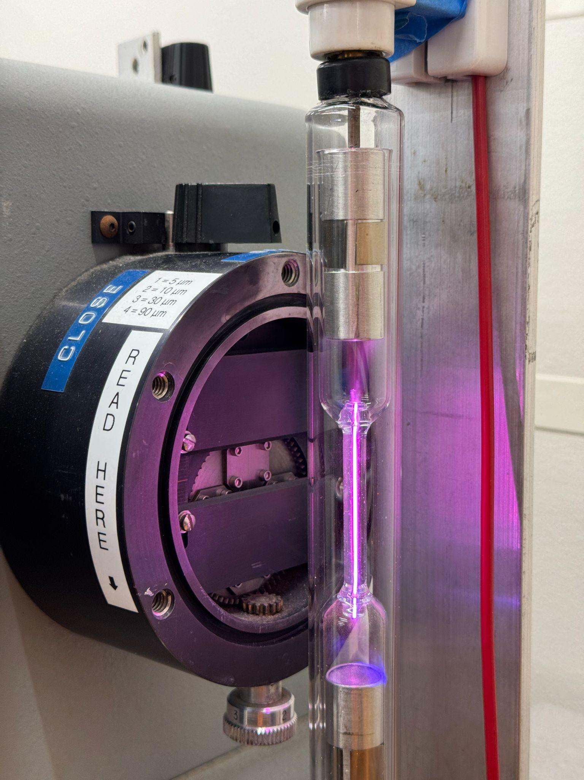

13:18 saw data really different from last time. Asked TA for help

13:30 collected trail 1 doublet data at around 6560 under a sweeping speed of 5. [6559-6561_L-H_trail_1.csv](https://drive.google.com/file/d/1J4NHw69j-Qwu4nDZERAQE6Bav4S7qKWM/view?usp=drive_link)

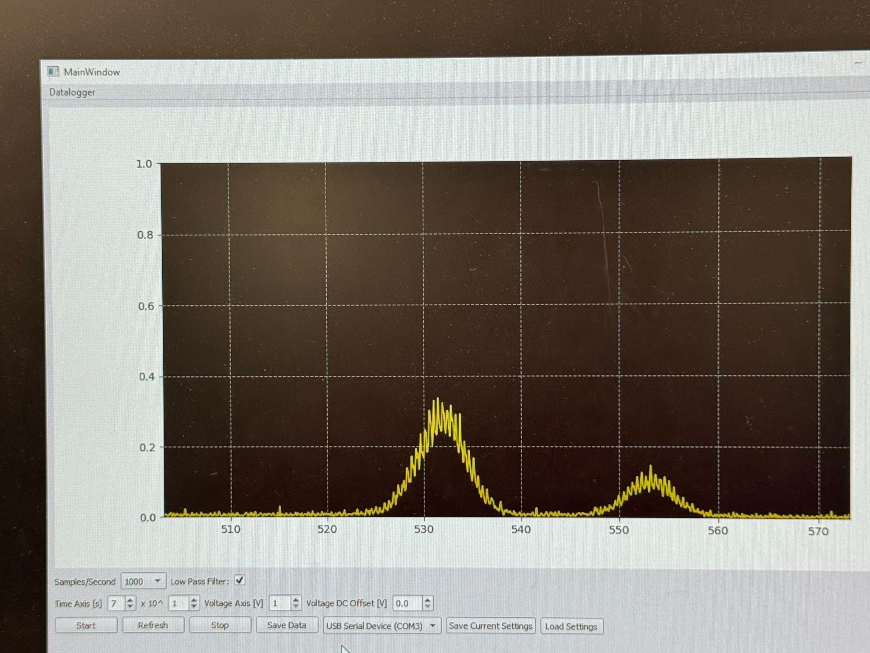

13:39 6559 - 6561 trail 2 [6559-6561_L-H_trail_2.csv](https://drive.google.com/file/d/1qkOXJdYmJdBCqH4RtOqffYQflcMXcsNP/view?usp=drive_link)

13:45 6559 - 6561 trail 3 [6559-6561_L-H_trail_3.csv](https://drive.google.com/file/d/1S5UhC9CwND3EnUO90VxbeoGa8ASljhlC/view?usp=drive_link)

13:48 6559 - 6561 trail 4 [6559-6561_L-H_trail_4.csv](https://drive.google.com/file/d/1FjkxW8MPScLdShW222KMqRZpZ5IPYdGX/view?usp=drive_link)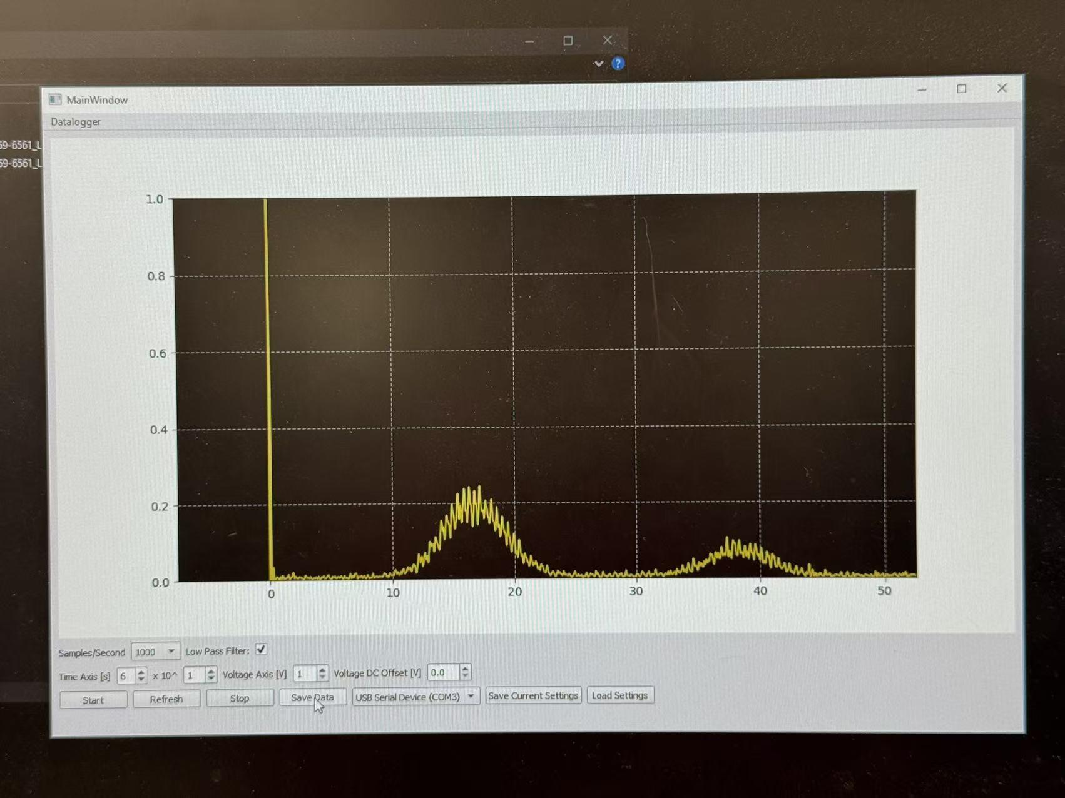

13:52 finding the peak of the second doublet. We found that the signal goes weak and almost negligible, so we turned the slit to 4 (90μA) and seeping speed of 1. We weren’t able to identify any peak

13:58 we identified the the first peak of the doublet at around 4860 when sweeping from low to high wavelength, but we cannot identify the second peak

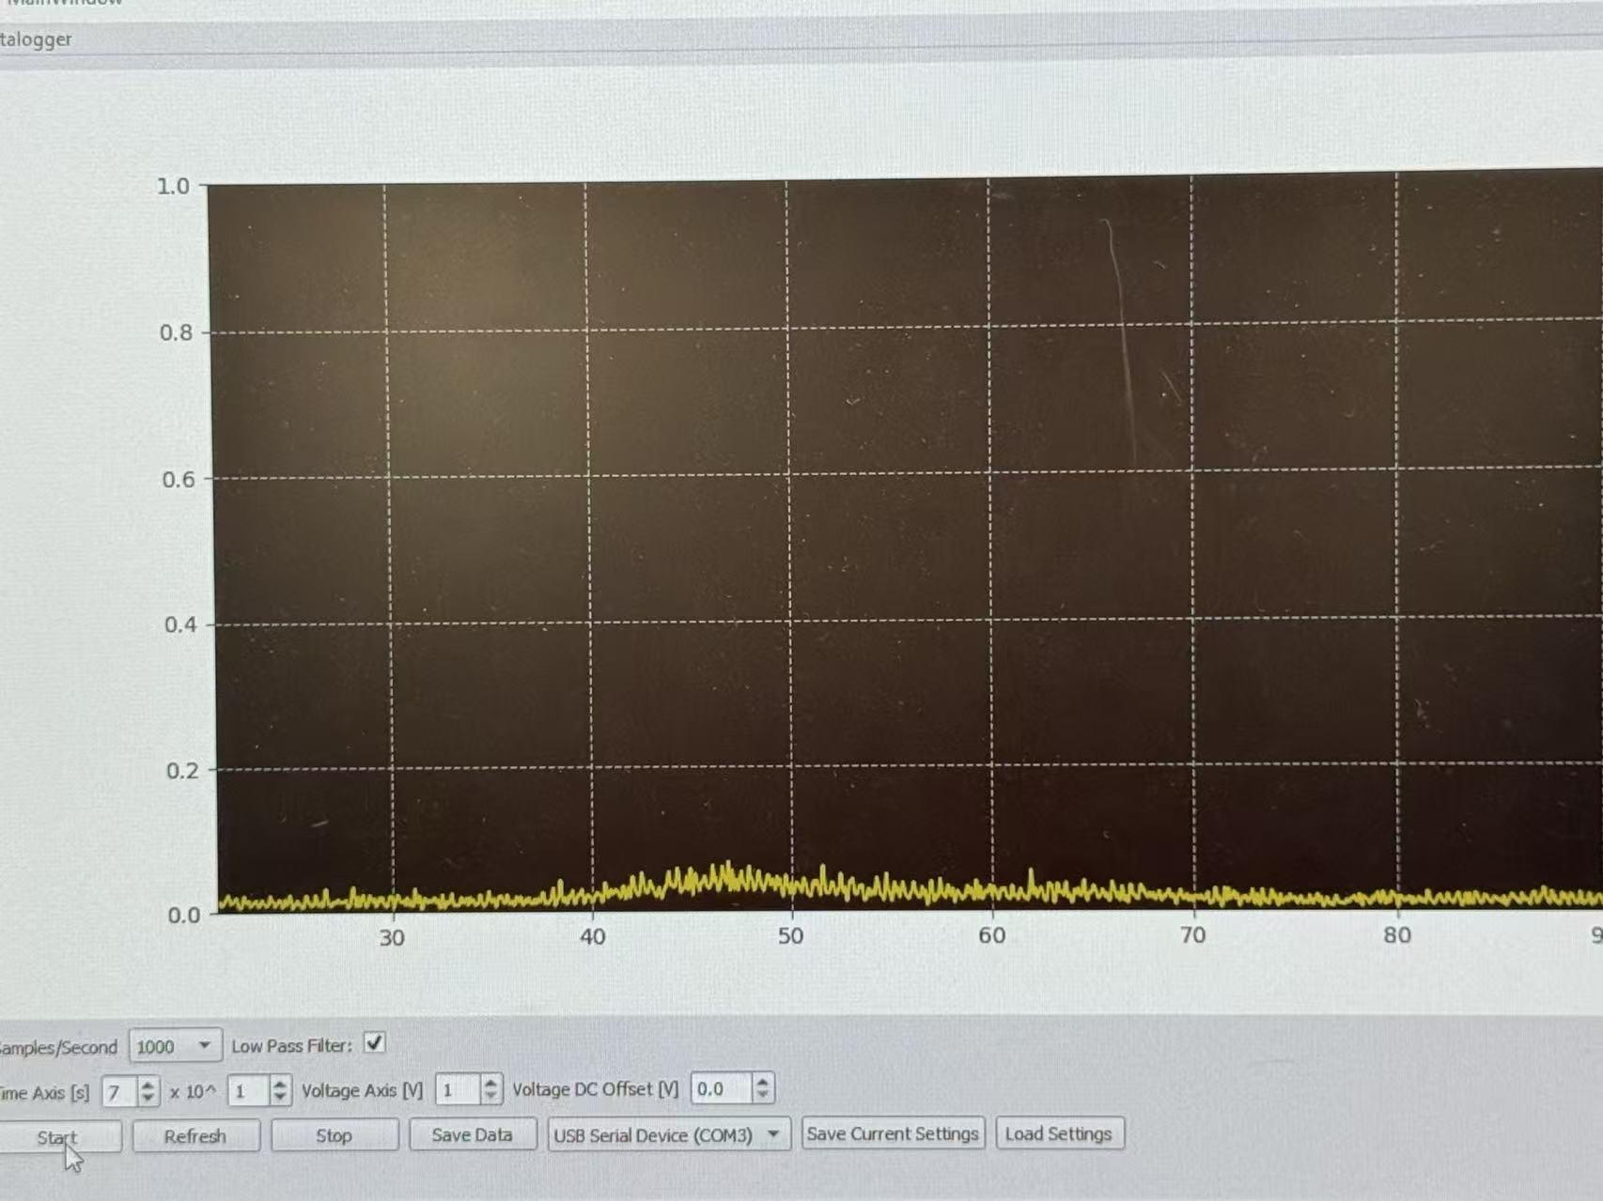

14:00 we changed the range of the picoammeter to 20nA. Found the doublet!

14:04 4859-4862 trail 1, High to low wavelength. [4859-4862_H-L_trail_1.csv](https://drive.google.com/file/d/1-Xjvlsqv_uBWtMwrskEb1M0I90KCu3eb/view?usp=drive_link)

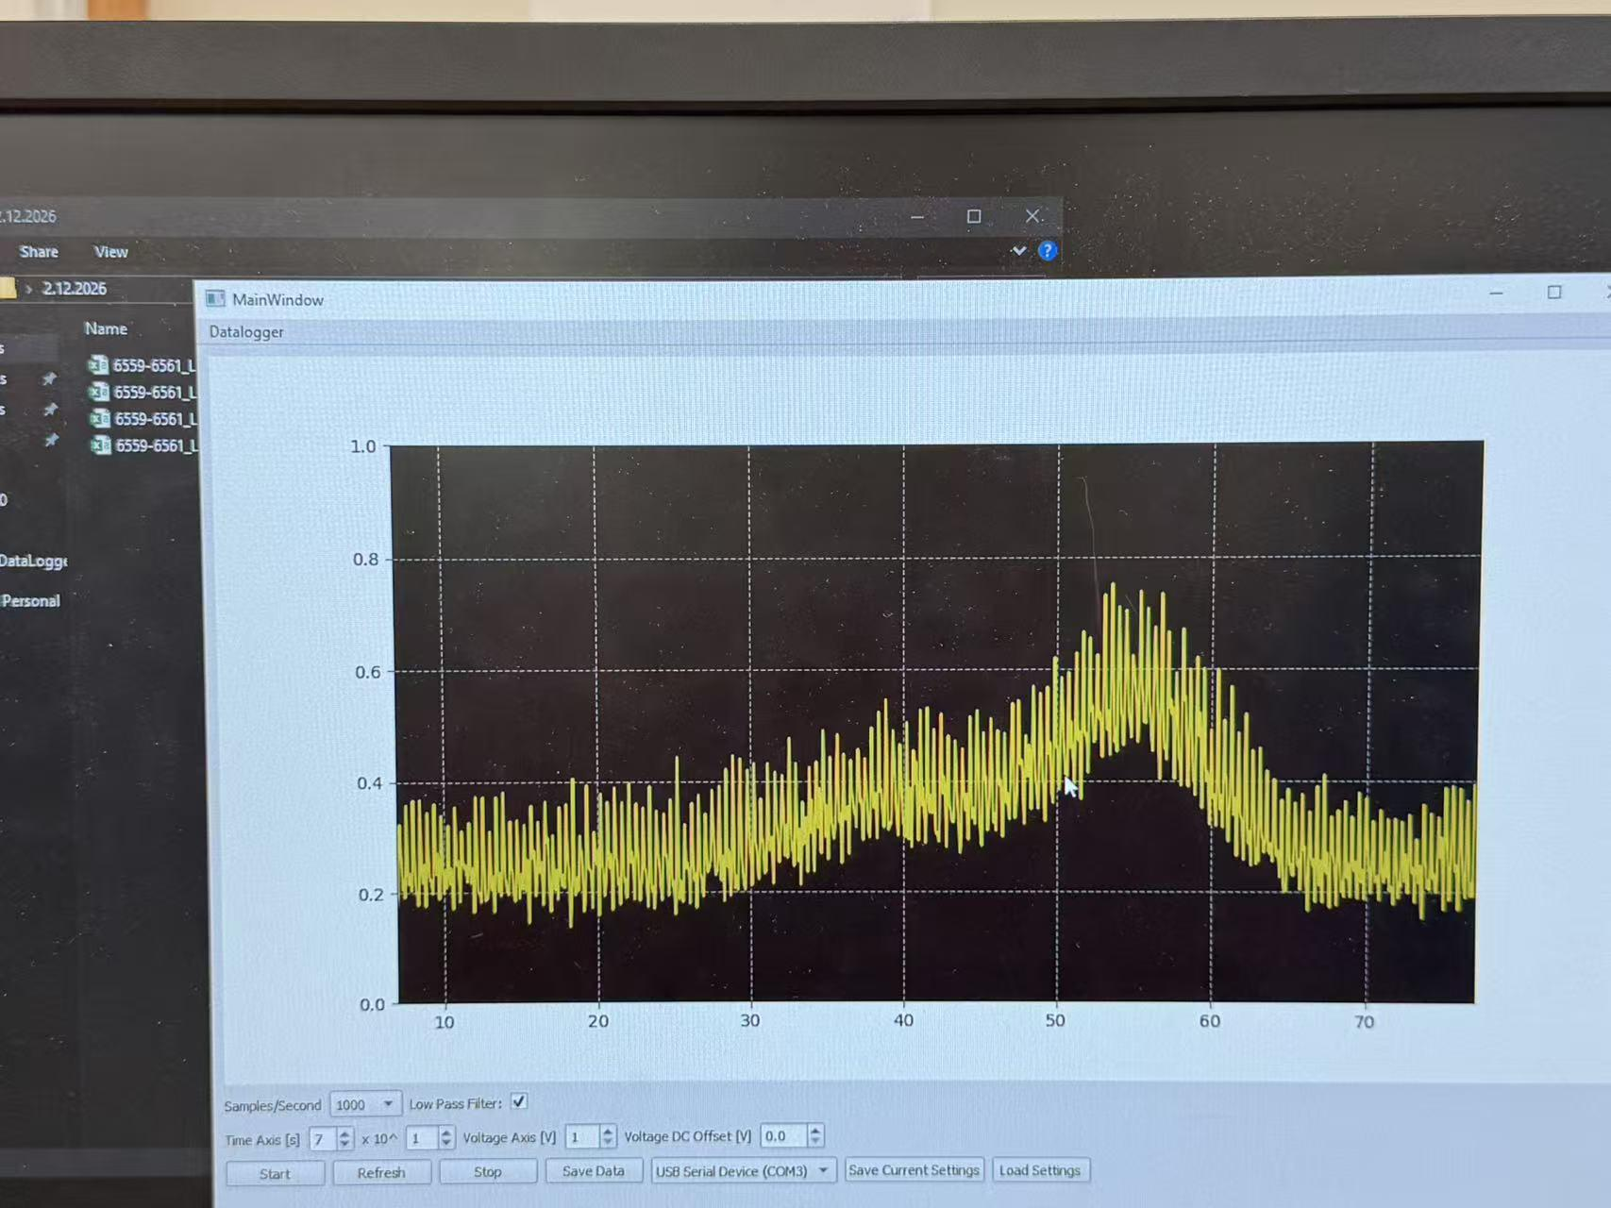

14:07 4859-4862 trail 2 [4859-4862_L-H_trail_2.csv](https://drive.google.com/file/d/1aOCIIiQBcaeZWaCgMDpy1f9yFCR6YVhD/view?usp=drive_link)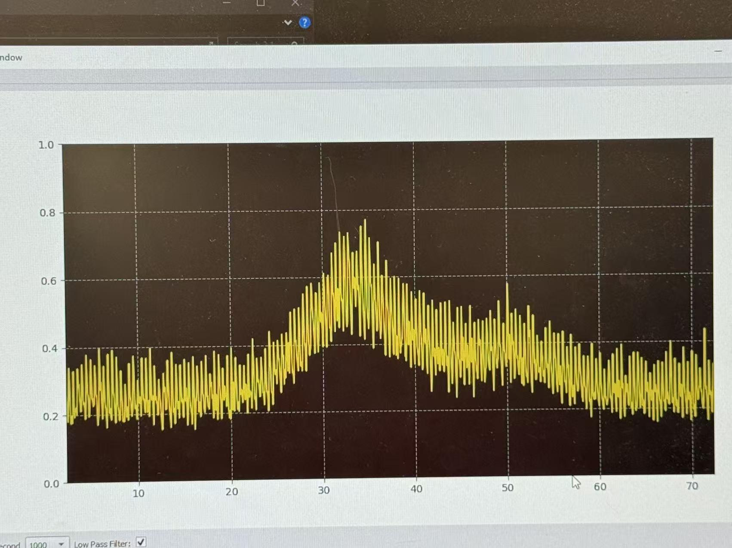

14:09 the 3rd trail has quite significant uncertainty, we decided to collect better ones

14:11 4859-4862 trail 3 [4859-4862_L-H_trail_3.csv](https://drive.google.com/file/d/1lrL1cno-iIIVYNHmyxBBrs--4ZhjPXDI/view?usp=drive_link)

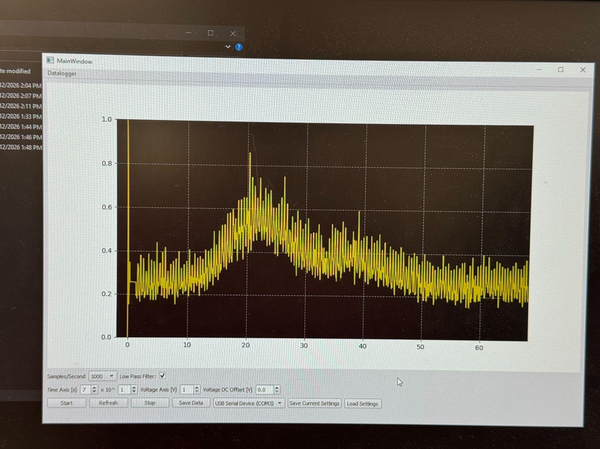

14:13 4859-4862 trail 4 [4859-4862_L-H_trail_4.csv](https://drive.google.com/file/d/1V1NV8qw0M6JouktOOQTwl3yMoLQPYNHQ/view?usp=drive_link)

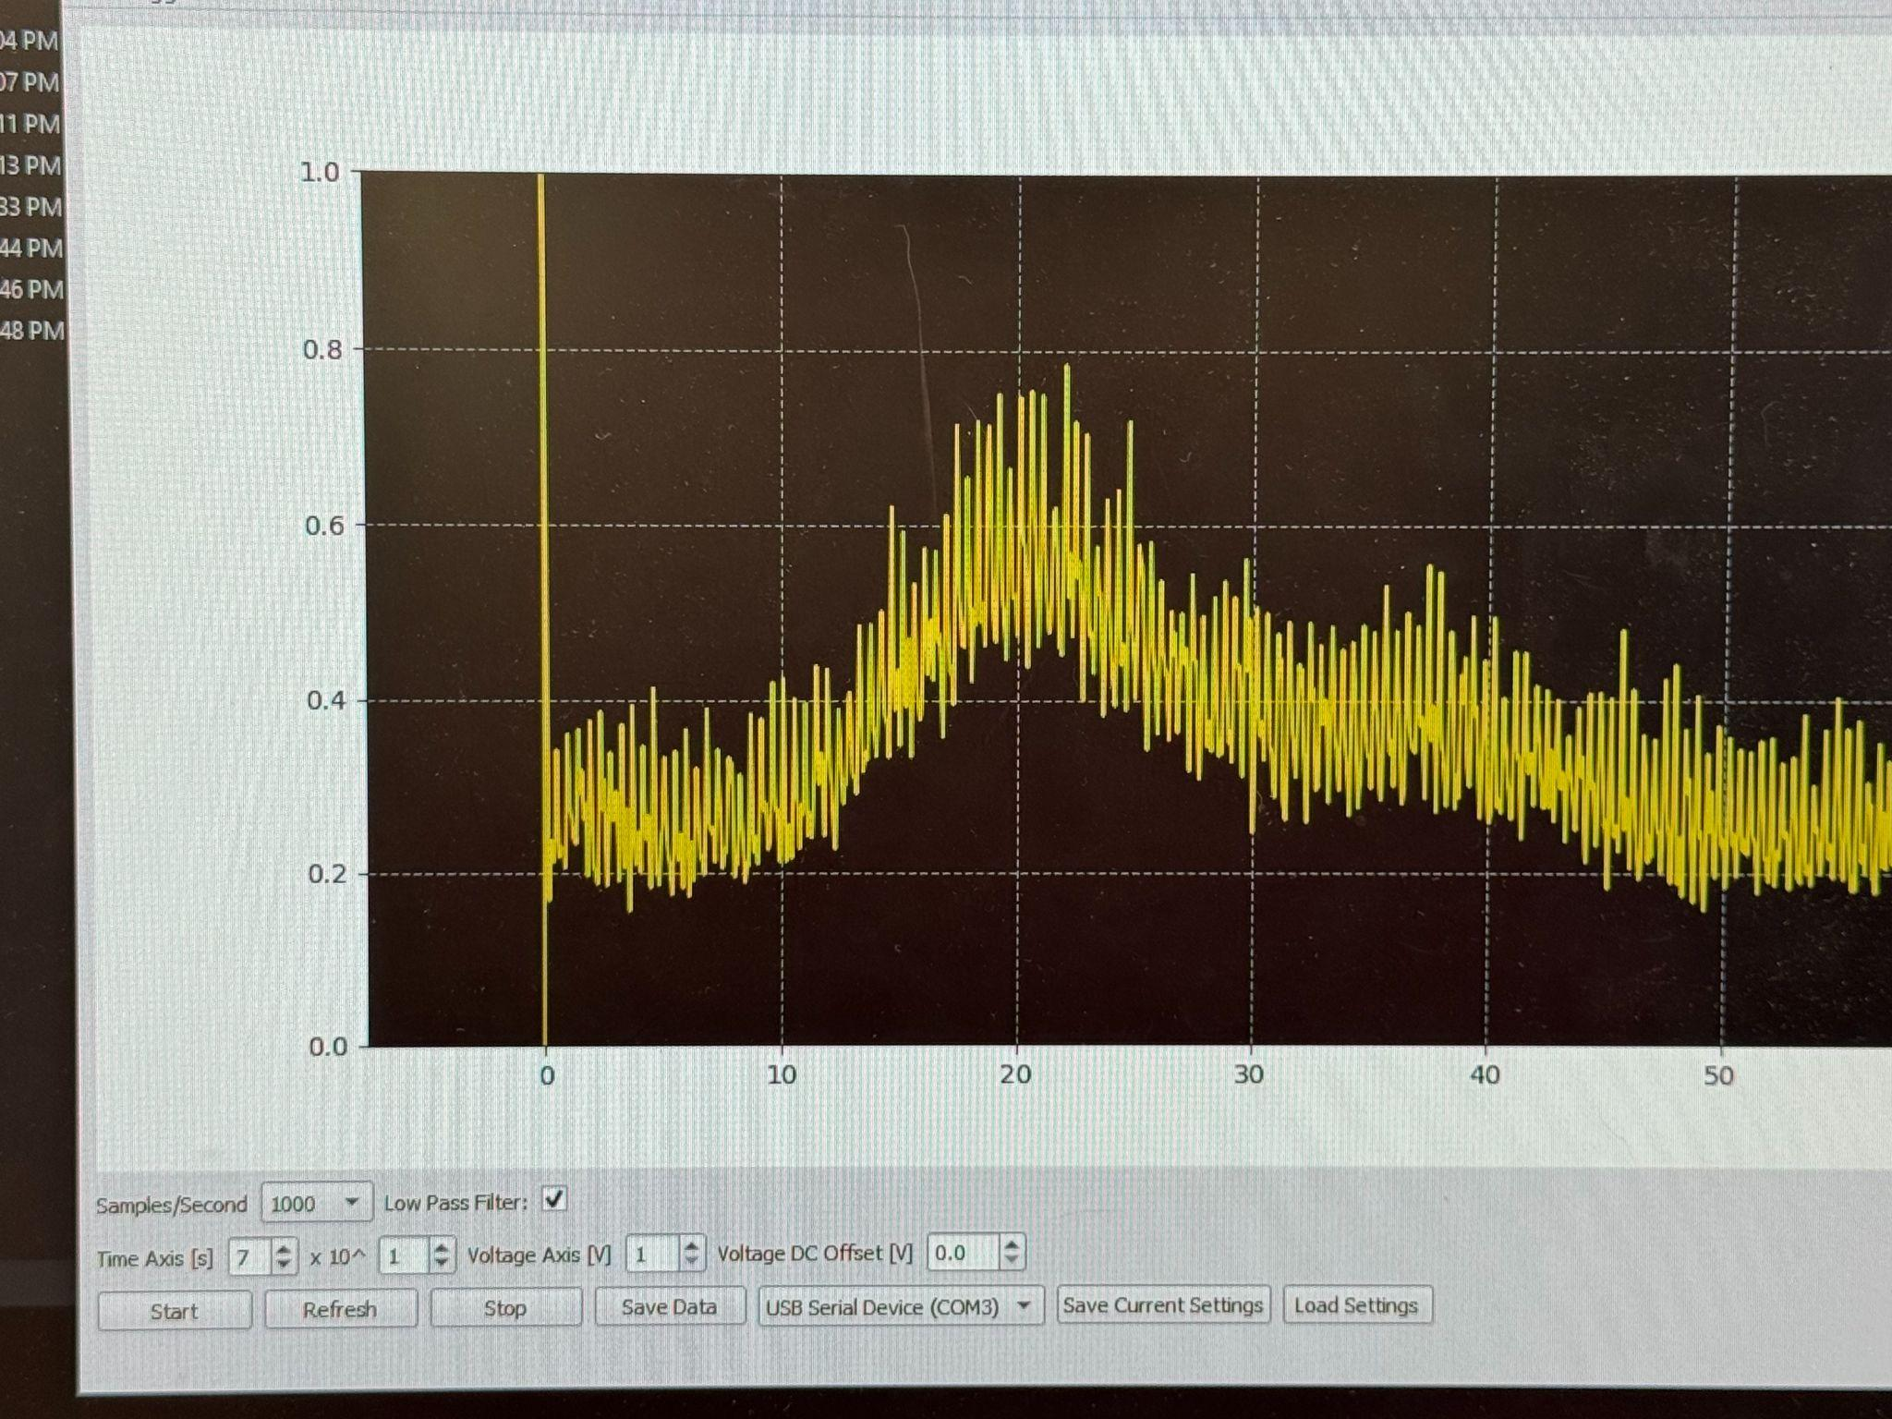

14:23 After trying changing the range of picoammeter and the slit width to 90μA, scanning at sweeping speed of 5 (it got worse when the sweep speed gets lower then 5), it is still unable for us to find the doublet peak at around 4339. This scenario has been understood as an unknown systemic issue due to either the H-D light or the monochromator. We will carry out uncertainty propagation and data analysis with the data of two peaks we have in hand in the lab report.

# 

# Uncertainty Propagation Method for Day 4 Data

From the background information we already know, Hydrogen (H) has a larger de Broglie wavelength than Deuterium (D) when moving at the same velocity. So the wavelength of the higher peak is the Deuterium’s wavelength, and the wavelength of the lower peak is the Deuterium’s wavelength.

For uncertainty propagation, as the doublets we have today would not be properly fit to a gaussian distribution, the TA suggested us to propagate uncertainty “by eye.” which means that, for the wavelength, we will take the highest value for each peak, two for each doublet; and the uncertainty of wavelength for the two peaks of each doublet will be measured in the method demonstrated below:

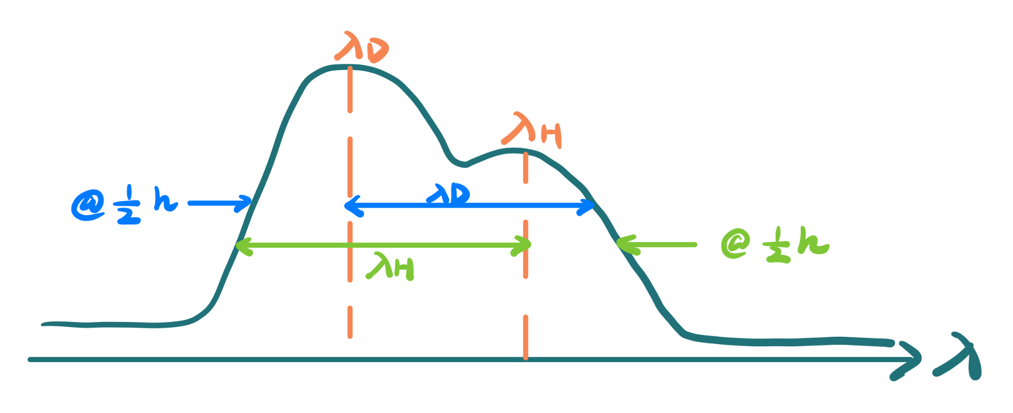

Due to limited time, we will carry out more precise calculation and uncertainty propagation in our separate lab report based on this method.

# 

# Conclusion and Discussion

In this experiment, we aimed to measure the isotope shift between hydrogen and deuterium in the Balmer series using the spectrometer and photomultiplier tube system. The goal was to resolve the very small wavelength difference (on the order of 1 Å) between the hydrogen and deuterium emission lines and compare our measurement with the theoretical prediction based on the reduced mass correction to the Rydberg formula. Overall, we were able to successfully calibrate the spectrometer using the Hg doublet near 6263 Å and then measure the H–D doublet around 6562 Å.

From our Gaussian fit of the 6562 Å doublet, we obtained two peak centers separated by Δt = 22.54564 s. Using the scan speed of 5 Å/min (0.08333 Å/s), this corresponds to a wavelength separation of Δλ = 1.8788 Å. This value is reasonably close to the theoretical prediction (~1.785 Å from our pre-lab calculation), suggesting that our experimental method was working properly at least for the strongest Balmer line (Hα). The uncertainties from the fit were relatively small (on the order of 10⁻³ Å), indicating that our statistical precision for this line was good.

However, we encountered several challenges during the experiment. As we moved to shorter wavelengths (4337 Å, 4098 Å, and below), the signal became much weaker and in some cases completely disappeared. Even after adjusting slit widths, picoammeter range, sweep speed, and lamp alignment, we were not always able to clearly resolve the doublets. There were also some inconsistencies between lab days, possibly due to lamp stability or monochromator alignment issues. These factors likely introduced systematic uncertainty that we have not yet fully quantified.

There are several ways the experiment could be improved. First, more careful and consistent alignment of the H–D lamp with the entrance slit would likely improve signal strength, especially at shorter wavelengths. Second, keeping the scan direction and sweep speed strictly consistent for all trials would help reduce mechanical backlash effects. Third, recording more trials for each Balmer line and averaging the results would reduce statistical uncertainty. Finally, ensuring that the monochromator and lamp are fully stable before beginning measurements would improve reproducibility.

In conclusion, although we were not able to successfully measure all six Balmer lines, we did clearly observe and quantify the isotope shift for the Hα line. Our measured value is reasonably consistent with theoretical expectations, and the experiment demonstrates how a small correction from reduced mass leads to a measurable shift in atomic spectra. A more complete uncertainty analysis and comparison for additional lines will be included in the final lab report.